An Example of a Manuscript: Submission to Letters on Evolutionary Behavioral Science

Shinya Yamamoto^{1,*}, Yohsuke Ohtsubo²

¹Kyoto University, Yoshida-Honmachi, Sakyo-ku, Kyoto 606-8501, Japan
²Kobe University, 1-1 Rokkodai-cho, Nada-ku, Kobe 657-8501, Japan

*Author for correspondence (lebs_editor@hbesj.org)

short title: An example for submission to LEBS

Abstract
Manuscript must be a single MS Word file containing all graphics, tables, and an abstract. The Word file must be submitted through the editorial system at https://lebs.hbesj.org/ with a cover letter, which contains the title, short title, author's name, affiliation, telephone and fax numbers, and electronic mail address of the corresponding author. The cover letter should contain an abstract in a text format as well as word count for the review purpose.

Keywords
Insert 3–6 keywords here.

Introduction
The main text should be approximately 2,500 words. This does not include a cover page, references, acknowledgments, and figure/table legends.

Methods
The style of the Publication Manual of the American Psychological Association (APA Manual; 7th Edition) must be followed with respect to handling references, footnotes, tables and figures, and abbreviations and symbols.

Results
Each table and figure should be embedded within the text after its first callout. Alternatively, tables and figures may be placed on separate pages after the reference list.

Discussion
For in-text citations, follow the APA 7th ed. style. For a work with one or two authors, include the surname(s) of the author(s) in every citation. For a work with more than three authors, include the first author’s surname only, and it must be followed by “et al.” in every citation (note that “et al.” should not be underlined). When this rule results in the same in-text citation because the same first author published multiple papers with his/her co-authors in the same year, please refer to the APA publication manual 7th ed.
Cite references in the text as, for example, “Hasegawa and Hiraiwa­Hasegawa (1983)” or, if in parentheses, as (Hiraiwa­Hasegawa, 1993). Use lower­case letters to distinguish between two papers by the same authors in the same year (e.g. Oda, 2002a, 2002b). List multiple citations in alphabetical order (e.g. Hiraiwa­Hasegawa, 1993; Nakamaru, 2006; Oda, 2001), using a semicolon to separate each reference. Cite references in the reference list in alphabetical, and then chronological, order according to the authors’ surnames and dates.
For papers in the course of publication, use “in press” to replace the date and give the journal name in the references. For unpublished work, please refer to Section 10.8 of the APA publication manual 7th ed. Authors can submit supplemental files that will be published online.

Acknowledgments
We would like to thank Kohei Tamura, Motohide Seki, and Masahito Morita for their help. This study was financially supported by JSPS KAKENHI ######.

Author contribution
SY developed the study concept and design, and YO collected and analyzed data. SY and YO wrote the manuscript.

Ethical statement
If the study made use of human or animal subjects and/or tissue, you must provide an ethics statement.

Data accessibility & program code
The authors are also solicited to make all the data they used accessible in supplemental files or open-access databases.

Supplementary material
Electronic supplementary materials are available online.

References
Darwin, C. (1859). On the origin of species by means of natural selection. John Murray.
Hasegawa, T., & Hiraiwa-Hasegawa, M. (1983). Opportunistic and restrictive matings among wild chimpanzees in the Mahale Mountains, Tanzania. Journal of Ethology, 1, 75–85. https://doi.org/10.1007/BF02347833
Oda, R. (2001). Lemur vocal communication and the origin of human language. In T. Matsuzawa (Ed.), Primate origins of human cognition and behavior (pp. 115–134). Springer-Verlag.
Oda, R., Naganawa, T., Yamauchi, S., Yamagata, N., & Matsumoto-Oda, A. (2009). Altruists are trusted based on non-verbal cues. Biology Letters, 5(6), 752–754. https://doi.org/10.1098/rsbl.2009.0332

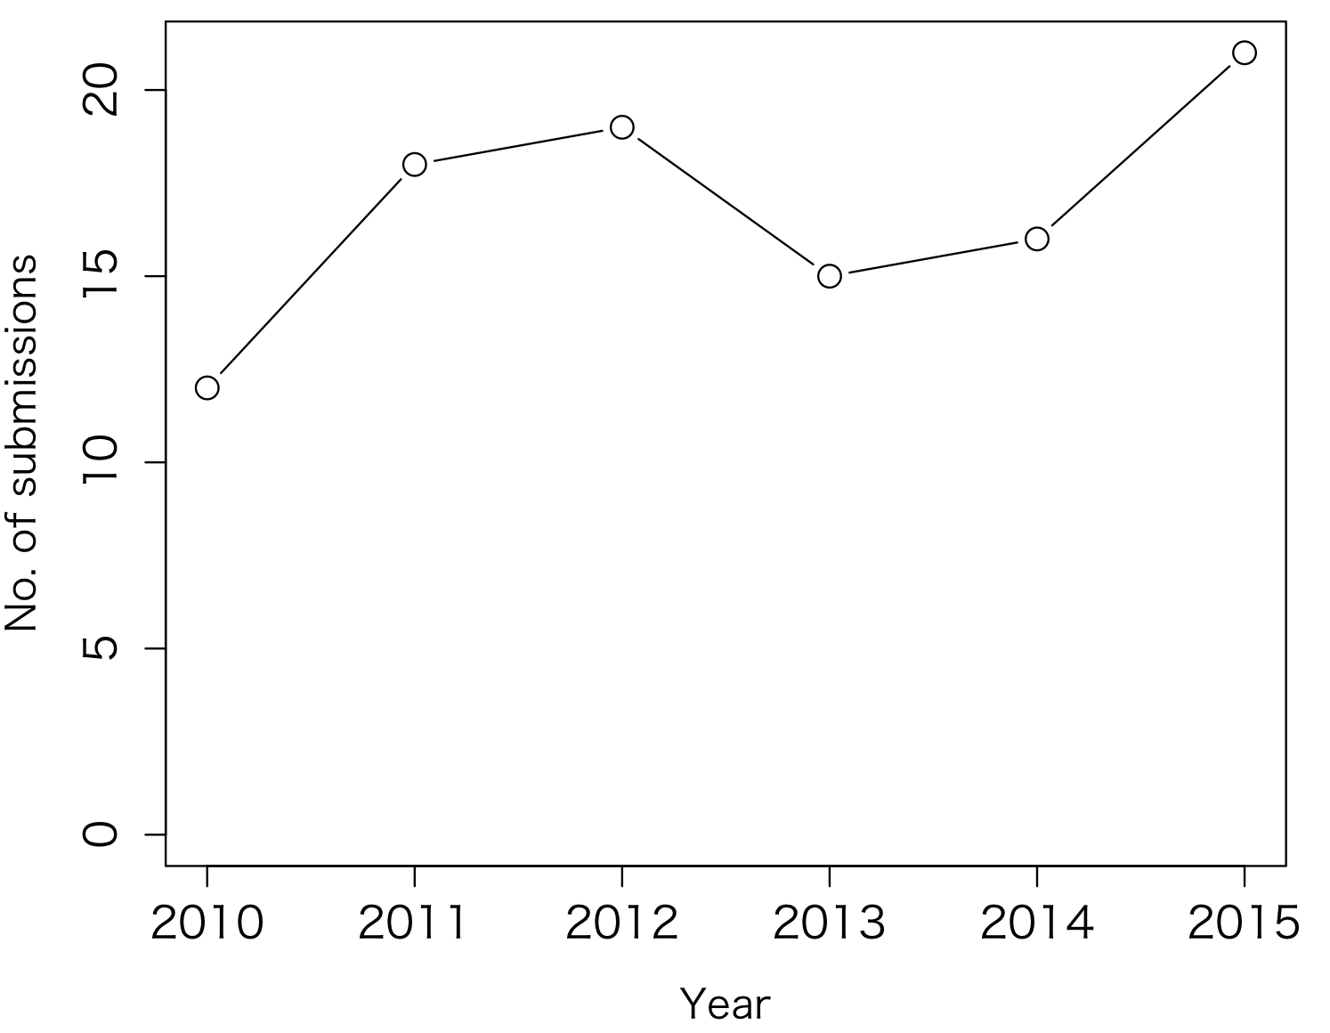
Figure 1. The number of articles submitted to LEBS.

