Letters on Evolutionary Behavioral Science

Supplemental Information for

Revisiting the Prosocial Effect of Interpersonal Synchrony in Infants: A Study Under a Pre-Post Manipulation During the COVID-19 Pandemic
Kaho Todoriki^{1,2,†,*}, Lira Yu^{3,†}, & Masako Myowa¹
¹ Kyoto University, Yoshida Honmachi, Sakyo-ku, Kyoto 606-8501, Japan
²The Japan Society for the Promotion of Science
³ Wildlife Research Center of Kyoto University, 2-24 Tanaka-Sekiden-cho, Sakyo-ku, Kyoto 606-8203, Japan

†These authors contributed equally to this work and share first authorship.

* Correspondence: bpkortaasi.47@gmail.com

Method
Apparatus and Stimuli
The floor plan of the experimental room is shown in Figure S1. The room was 3.67 m wide and 3.11 m deep. During the helping task phase (Figure S1A), a desk (70 cm × 70 cm × 70 cm) was placed on one side of the room. The following objects were used in the helping task phase: sticks (length: 10.90 cm, diameter: 1.00 cm, 12 g), blocks (volume: 36.29 cm³, 20 g), paper balls (diameter: 4.00 cm), and clothespins (length 6.00 cm, longest width: 3.00 cm, tip width: 1.20 cm, 3 g). During the interpersonal movement phase (Figure S1B), the desk was removed and a speaker (Fostex PM0.1) was placed between Experimenters A and B.
Similar to Cirelli et al. (2014), the Beatles’ song “Twist and Shout” was used as the experimental stimulus for the interpersonal movement phase and played through the speaker. The soundtrack was set at 100 beats per minute (BPM) for both the synchronous and asynchronous conditions and was 140 seconds long. In addition, the two experimenters heard metronome sound through wireless earphones (TRUEFREE+, SOUNDPEATS) that signaled the timing of the bounce. Experimenter B, who was holding the infant, heard a metronome sound at 100 BPM regardless of the condition. Experimenter A heard metronome sound of 100 BPM in the synchronous condition and 140 BPM in the asynchronous condition.

Figure S1. Room layout and apparatus placement during (A) helping tasks phase and (B) interpersonal movement phase.
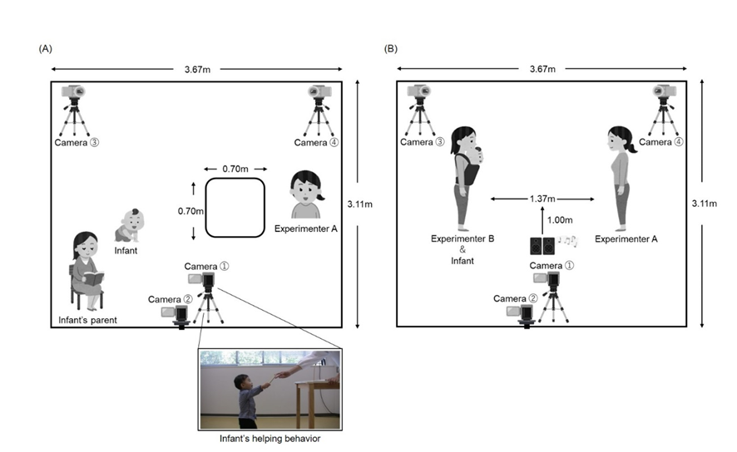

Procedure
Upon arrival at the experimental room, the infant first played with Experimenter B for approximately 10 minutes next to the parent. During this time, Experimenter B showed the infant two of each of the sticks, blocks, balls, and clothespins that would be used in the subsequent helping task. After the infants became familiar with the experimental room, the experiment began.

(a) Helping Tasks Phase
The flow of each helping task was as follows: The stick task: Experimenter A stabbed one wooden stick into a stand with a hole in it. She then tried to stab another wooden stick and accidentally dropped it on the floor. The block task: Experimenter A stacked one block on top of a block. She then tried to stack another block on top of it and accidentally dropped it on the floor. The ball task: Experimenter A put a ball in a bucket. She then tried to put another ball in the bucket and accidentally dropped it on the floor. The clothespin task: Experimenter A clipped a cloth to a clothespin. She then tried to clip the cloth with another clothespin and accidentally dropped it on the floor. The order of tasks within Sets A and B was fixed (in Set A, the stick task was always followed by the block task; in Set B, the ball task was always followed by the clothespin task).
If the infant handed the object to Experimenter A or placed the object on the desk, Experimenter A retrieved the object, achieved the goal (e.g., placing the ball in the bucket in the case of the ball task), and proceeded to the next trial. If the infant did not attempt to approach, hand, or place the object on the table after 30 seconds, Experimenter A said, “It’s no use, I’ll use [object name] from here,” and took a spare object from a basket nearby, thereby achieving the goal and proceeding to the next trial. Experimenter A did not say any words that would be rewarding to the infant. During the trial, Experimenter B presented the elapsed time cue to Experimenter A. The infant’s parent was instructed to read a book in the back of the experimental room and was asked not to speak to or make eye contact with the infant.

(b) Interpersonal Movement Phase
Experimenters A and B faced each other at a distance of 1.37 m. Music and metronome sounds were presented through speakers and earphones, respectively. In the synchronous condition, both experimenters bounced (repetitive knee bending and stretching movements) to the 100 BPM soundtrack. In the asynchronous condition, Experimenter A bounced faster (140 BPM) than Experimenter B. Experimenter B bounced at the same speed (100 BPM) as in the synchronous condition. During the bounce, Experimenter A looked into the infant’s eyes while smiling, as in the previous study (Cirelli et al., 2017), regardless of condition. The parent waited behind the partition out of sight of the infant.

(c) Questionnaire
To minimize time spent in the experimental room due to the coronavirus pandemic, parents completed the questionnaire at home after the experiment. Parents rated on a 7-point scale from 1 (never observed) to 7 (always observed) the infant’s behavior observed in the past week or two. If the parent did not observe the situation of the questioned item, they selected X (does not apply).

Data Processing
(a) Helping Rate
If the infant handed the object to Experimenter A within 30 seconds or placed it on the desk within 10 seconds, the infant received 1 point. If the infant handed the object to Experimenter A after 30 seconds or placed it on the desk after 10 seconds, the infant received 0.5 points. Experimenter A coded all videos, and two independent raters coded a total of 28% of the videos. Coding by Experimenter A and each rater was almost perfectly matched (κ = 1.00, κ = .93).
The helping rate pre- and post-interpersonal movement phase did not assume normality in both the synchronous (W = .66–73, p < .01) and asynchronous (W = .59–66, p < .01) conditions. The helping rate for each time window in which Experimenter A changed behavior (0–10 seconds, 10–20 seconds, 20–25 seconds, 25–30 seconds, and 30– seconds) also did not assume normality for both the synchronous (W = .25–65, p < .01) and asynchronous (W = .25–60, p < .01) conditions. Please note, however, that statistics and p-value were not calculated for the 20–25 second and 25–30 second time windows pre-interpersonal movement phase of the asynchronous condition, because the helping rate was 0% for all infants. To examine the effects of interpersonal synchronous and asynchronous experiences on infants’ helping behavior, Wilcoxon signed-rank test was conducted using Rstudio software (version 4.2.2).

(b) Temperament Scores
One infant who participated in the asynchronous condition was excluded from this analysis because the parent did not respond to the questionnaire. SUR included six subscales (i.e., approach, vocal reactivity, high-intensity pleasure, smiling and laughter, activity level, and perceptual sensitivity), which represent the temperament to approach people or objects or to display a smile or active physical movement (e.g., “When visiting a new place, how often did your baby get excited about exploring the new surroundings?”). NEG included four subscales (i.e., sadness, distress to limitations, fear, and falling reactivity), which represent temperaments, such as crying when a desire is not met or responding with surprise or fussiness to sudden or new stimuli (e.g., “For no apparent reason, how often did your baby appear sad?”). REG included four subscales (i.e., low-intensity pleasure, cuddliness, duration of orienting, and soothability), which represent the temperament that maintains attention to one target or prefers contact with caregivers (e.g., “How often during the last week did the baby look at pictures in books and/or magazines for 2–5 minutes at a time?”). Note that low correlations between each factor were reported in the study that developed the original version of the scale (Gartstein & Rothbart, 2003). Correlational analyses were conducted using Rstudio software (version 4.2.2) to examine the relationship between the infant’s temperament traits and the effects of interpersonal synchronous and asynchronous experiences.

