**Supplementary Material**

Title: *Examining the Possibility of Maladaptive Cultural Evolution through Oblique Transmission*

Author: Chinatsu Sano and Masanori Takezawa

Appendix S1. Analyzing the selection pressure for the rate of oblique transmission.

This section shows that when the environment does not change between the consecutive generation *t* and *t* + 1, the oblique transmission rate (*ao*) receives negative selection pressure. On the other hand, the direction is reversed when the environment changes between *t* and *t* + 1.

Let $p$ be the frequency of parents having the adaptive trait at *t*, $p'$ be the frequency of children born to parents with the adaptive trait at *t,* and $o$ be the rate of oblique transmission (symbolized *ao* in the main text). In the entire section, we assume a very large population.

**When the environment does not change between generation *t* and *t* + 1:**

Children born to parents with the adaptive trait at *t* acquire the adaptive trait at *t* + 1 with the probability $\left(1-o\right)+op$. Children born to parents with a maladaptive trait acquire the adaptive trait with the probability $op$. Then, the probability children with the oblique transmission rate $o$ can acquire the trait that will be adaptive at generation *t* + 1 is:

$$f=p^{'}⋅\left\{\left(1-o\right)+op\right\}+\left(1-p'\right)⋅op$$

$$=p^{'}\left(1-o\right)+p^{'}op+op- p^{'}op \\ =p^{'}\left(1-o\right)+op.$$ Next, we want to show that, as the oblique transmission rate (*o*) increases, children’s probability of acquiring the adaptive trait at generation *t* + 1 ($f$) decreases. Suppose that the fitness value for a maladaptive trait is 1 and $1+α$ for the adaptive trait, respectively. The frequency of children born to adults with the adaptive trait is $p'=\frac{p(1+α)}{p\left(1+α\right)+(1-p)}=\frac{pα+p}{pα+1}$. Substituting this into the above equation, $f$ becomes:

$$f= \frac{pα+p}{pα+1}\left(1-o\right)+op \\ =\frac{pα+p}{pα+1}-o\frac{pα+p}{pα+1}+op \\ =\frac{pα+p}{pα+1}+o\left(p-\frac{pα+p}{pα+1}\right).$$

Differentiation of $f$ with respect to $o$ gives $f^{'}\left(o\right)=p-\frac{pα+p}{pα+1}=\frac{α\left(p^{2}-p\right)}{pα+1}$. When $0<p<1$, $f^{'}\left(o\right)<0$. This implies that the oblique transmission rate is negatively correlated with children’s probability of acquiring the adaptive trait at generation *t* + 1.

**When the environment changes between generation *t* and *t* + 1:**

Suppose that the number of cultural traits $c=n$ and the frequency of maladaptive traits are equal for the simplicity. One of the $n-1$ maladaptive cultural traits at *t* will be randomly chosen and become the adaptive trait at *t* + 1. So, children born to parents with the adaptive trait at generation *t* acquire the adaptive trait at *t* + 1 with the probability $\frac{o⋅(1-p)}{n-1}$. On the other hand, children born to parents with a maladaptive trait at *t* acquire the adaptive trait at *t* + 1 with the probability $\frac{\left(1-o\right)}{n-1} +\frac{o⋅(1-p)}{n-1}=\frac{1-op}{n-1}$. When the children’s oblique transmission rate is $o$, the probability children acquire the trait that will be adaptive at generation *t* + 1 is:

$$g= p^{'}⋅\frac{o⋅\left(1-p\right)}{n-1}+\left(1-p^{'}\right)⋅\frac{1-op}{n-1} \\ =\frac{p^{'}\left(o-1\right)+1-op}{n-1}.$$

Next, we want to show that, as the oblique transmission rate (*o*) increases, children’s probability of acquiring the adaptive trait at generation *t* + 1 (*g*) increases.

$$g= \frac{\frac{pα+p}{pα+1}\left(o-1\right)+\left(1-op\right)}{n-1} \\ =\frac{o\left(\frac{pα+p}{pα+1}-p\right)-\frac{pα+p}{pα+1}+1}{n-1}$$ Differentiation of $g$ with respect to $o$ gives:

$$g^{'}\left(o\right)=\left(\frac{pα+p}{pα+1}-p\right)⋅\frac{1}{n-1} \\ =\left(\frac{pα(1-p)}{pα+1}\right)⋅\frac{1}{n-1}.$$

When $0<p<1$, $f^{'}\left(o\right)>0$. This implies that the oblique transmission rate positively correlates with the children’s probability of acquiring the adaptive trait at *t* + 1.

Both $f^{'}(o)$ and $g^{'}\left(o\right)$ are the rate of change in the probability of acquiring the adaptive trait at *t* + 1. As the number of cultural traits (*n*) increase, $g^{'}\left(o\right)$ decreases. This implies that the positive selection pressure for the oblique transmission rate after the environment change becomes weaker as the number of cultural traits increases.

Appendix S2. Result of Simulation 1 with different initial conditions

 We examined the sensitivity of Simulation 1’s results against different initial conditions by starting the simulations from the high rate of oblique transmission (*io* = 1) and the high frequency of maladaptive cultural traits (*im* = 1).

Figure S2 shows the rate of oblique transmission (*ao*) (when *mu* = 0.01) at 5,000th generation averaged over 50 runs. Figures in the left and right columns are the results when there are two traits (*c* = 2) and five traits (*c* = 5), respectively. The top row shows the results when the initial frequency of a maladaptive cultural trait is 0 (*im* = 0). The middle and bottom rows show the results when the frequency of maladaptive cultural traits in the first generation is 1 (*im* = 1). The initial rate of oblique transmission is set to 0 (*io* = 0) for the two figures in the middle row and 1 (*io* = 1) for the two figures in the bottom row. The rows and columns of each figure represent the differences in fitness between maladaptive and adaptive traits (*VU* = 1, 0.1) and the probabilities of environmental changes (*e* = 0.01, 0.1, 0.2, 0.3, 0.4, 0.5), respectively.

As the two figures in the bottom row are identical to the results of Simulation 1 (Figure 1 in the main text), it is evident that changing the initial conditions for the rate of oblique transmission and the frequency of maladaptive cultural traits do not influence the results of Simulation 1.

**Figure S2** Results of the rate of oblique transmission (*ao*) (when *mu* = 0.01). The number in each cell averages over 50 runs at 5,000th generation. The left column(a, c, e) shows the results of when there are two traits (*c* = 2). The right column (b, d, f) shows the results when there are five traits (*c* = 5). The top row (a, b) shows the results of when the initial frequency of maladaptive cultural traits is 0 (*im* = 0), and the middle and bottom rows (c ~ f) show the results of when the initial frequency of maladaptive cultural traits is 1 (*im* = 1). The initial rate of oblique transmission is 0 for the middle row figures (c, d) and 1 for the top and bottom row figures (a, b, e, f). The rows and columns of each figure show the differences in fitness between maladaptive and adaptive traits (*VU* = 1, 0.1) and the probabilities of environmental changes (*e* = 0.01, 0.1, 0.2, 0.3, 0.4, 0.5), respectively.

Appendix S3. Results of Simulation 2 with a different initial condition

We examined the sensitivity of Simulation 2’s results against different initial conditions by starting with the higher initial frequency of maladaptive cultural traits (*im* = 1). Figure S3 shows the frequency of a maladaptive cultural trait at the 5,000th generation averaged over 50 runs (when *mu* = 0.01). The left column (a) and (c) and the right column (b) and (d) show the results when there are two traits (*c* = 2) and five traits (*c* = 5), respectively. The top row, (a) and (b), shows when there is no bias imitating maladaptive cultural trait (*s* = 1), and the bottom row, (c) and (d), shows when a maladaptive trait is twice more likely to be imitated (*s* = 2). Each rows and columns in the figures represent the differences in fitness between maladaptive and adaptive traits (*VU* = 1, 0.1) and the probabilities of oblique transmission (*ao* = 0.1, 0.3, 0.5, 0.7), respectively. Cells surrounded by bold lines use the evolved rate of oblique transmission in Simulation 1.

The obtained results resemble the top row (*s* = 1) and the bottom row (*s* = 2) in Figure 2. It is thus suggested that differences in the frequency of maladaptive cultural traits in the first generation did not significantly change the results of Simulation 2.

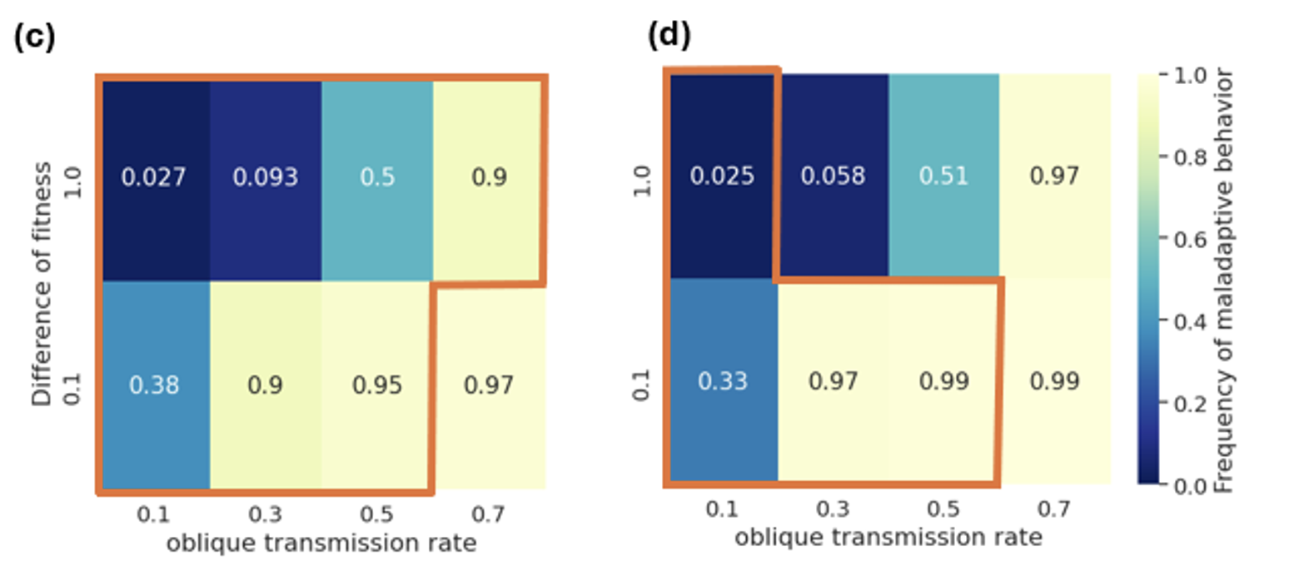

**Figure S3** Results of the frequency of maladaptive cultural traits (*m*) when the initial frequency of maladaptive cultural traits is 1 (*im* = 1; *mu* = 0.01). The number in each cell shows the frequency of maladaptive cultural traits at 5,000th generation averaged over 50 runs. The top row, (a) and (b), shows the results of when the frequency of there is no bias favoring maladaptive cultural trait to be imitated (*s* = 1); the bottom row, (c) and (d), shows the results when a maladaptive cultural trait is twice more likely to be imitated (*s* = 2). The left column, (a) and (c), shows the results when there are two traits (*c* = 2); the right column, (b) and (d), shows the results when there are five traits (*c* = 5). Rows and columns of each figure show the differences in fitness between maladaptive and adaptive traits (*VU* = 1, 0.1) and the probabilities of oblique transmission (*ao* = 0.1, 0.3, 0.5, 0.7), respectively. Cells surrounded by bold lines used the values of the oblique transmission rate (*ao*) evolved in Simulation 1.