Supplementary Information: Excessive altruism and its underlying motivation: Effects on likeability in Japan and the US

Study 1

Background of the hypothesis on caution
General trust and caution are individual characteristics involved in judging the trustworthiness of others. Caution is the belief that one should take appropriate actions to avoid danger in socially uncertain situations (Yamagishi, 1998). This study used a scenario in which the actors were asked to reveal their motivations for their excessively altruistic act. The scenario is designed in this way—where the motivation is self-reported—so as to present the possibility that the actor gave a false motivation while hiding the actual motivation. In such a situation where the truth is uncertain, the observer’s perception of the presented motivation may differ depending on the degree of caution. Those with low caution are expected to accept the presented motivation at face value and evaluate excessive altruistic behavior reportedly motivated by altruistic motivations more favorably. On the other hand, people with high caution may remain skeptical or unconvinced about the reported altruistic motivations, and make an unfavorable evaluation.

Details of Analysis Results omitted in the main document (Study 1)
The correlation analysis showed that liking was negatively correlated with selfish motivation and positively correlated with altruistic motivation (Table S1).

Table S1
Correlations and Descriptive Statistics for Each Variable (Study 1)
 | Variable | M | SD | 1 | 2 | 3 | 4 | 5
1 | Gender  (Male = 0) |  |  | －
2 | Age | 41.25 | 10.01 | -.12** | －
3 | Caution  (α = .75) | 4.99 | 0.87 | -.19** | -.03 | －
4 | Selfish motivation⁽¹⁾ |  |  | .07 | .04 | .01 | －
5 | Altruistic motivation⁽¹⁾ |  |  | -.02 | -.04 | .03 | -.51** | －
6 | Liking  (α = .85) | 4.35 | 1.40 | -.03 | .02 | .00 | -.26** | .22**
 | ⁽¹⁾Control = 0
 | *p < .05, **p < .01

Details of the discussion regarding the hypothesis not being supported
Study 1 did not support the hypothesis because there was no interaction between caution and motivational conditions. Several factors may have contributed to this result: first, this study was a scenario-based experiment. A previous experiment (Kikuchi et al., 1997) based on caution was conducted face-to-face, and the participants made judgments based on various non-verbal information, rather than a scenario. Therefore, it is possible that the responses to the scenarios did not fully reflect the judgmental tendencies of the participants with high caution. Although there are some studies using caution and the general trust scale as a set (Kikuchi et al., 1997), we have not found any studies focusing only on caution and examining its relationship with the altruism of others. This is because most of the studies using the general trust scale focus on the ability to correctly judge whether the other person is cooperative or not, that is, to recognize the intention of the other person and avoid being deceived. In the present study, it was not necessary to detect the true intentions of altruistic behavior; rather, the focus was on how participants evaluated the actors based on their altruistic behavior and their reported motivations. Therefore, we did not use a general trust scale, focusing only on the degree of caution. However, it may have been necessary to measure the degree of general trust as well. For example, Kosugi and Yamagishi (1998) conducted an experiment using scenarios and predicted that those with high general trust are more likely to predict others' trustworthiness as low and to act selfishly than those with low general trust in the case of scenarios containing negative information regarding others' trustworthiness. This suggests that individuals with high general trust are sensitive to information about others' trustworthiness. In the future, the relationship between general trust and caution should also be considered.

Study 2

Details of Analysis Results omitted in the main document (Study 2)
As in Study 1, liking was correlated with altruistic and selfish motivation. It was also positively correlated with country, independence, and harmony seeking (Table S2).

Table S2
Mean, Standard Deviations, Coefficient Alphas, and Correlations for the Main Variables (Japan vs US Comparison)
 | Variable | M | SD | 1 | 2 | 3 | 4 | 5 | 6 | 7 | 8
1 | Gender  (Man = 0) |  |  | ―
2 | Age | 41.54 | 12.46 | .02 | ―
3 | Country  (Japan = 0) |  |  | -.11** | .08* | ―
4 | Independence  (α = .93) | 4.81 | 1.35 | -.20** | .09* | .63** | ―
5 | Rejection avoidance  (α = .87) | 4.07 | 1.68 | .01 | -.30* | -.25** | -.41** | ―
6 | Harmony seeking  (α = .83) | 4.68 | 1.03 | -.10** | -.11* | .13** | .12** | .42** | ―
7 | Selfish motivation⁽¹⁾ |  |  | .06 | -.06 | .06 | .00 | .00 | -.04 | ―
8 | Altruistic motivation⁽¹⁾ |  |  | -.04 | .00 | -.03 | -.01 | .06 | .04 | -.55** | ―
9 | Liking  (α = .85) | 4.76 | 1.64 | -.07 | -.04 | .42** | .33** | .02 | .29** | -.11** | .12**
⁽¹⁾ Control = 0
*p < .05, **p < .01

Replication of Study 1
The correlation coefficients and descriptive statistics for each variable for the Japanese sample only are shown in Table S3. In order to examine the effect of the manipulation of motivations on liking, we conducted a multiple regression analysis with demographic variables, country, and manipulation of motivations as independent variables, and liking as the dependent variable (Table S4). Unlike Study 1, the negative effect of selfish motivations on liking was not significant, but there were differences in liking depending on the type of motivation, replicating the results of Study 1, in which altruistic motivations were evaluated more favorably.

Table S3
Correlations and Descriptive Statistics for Each Variable (Replication of Study 1)
 | Variable | M | SD | 1 | 2 | 3 | 4
1 | Age | 40.50 | 10.75 | ―
2 | Gender (Man = 0) |  |  | -.11* | ―
3 | Selfish motivation⁽¹⁾ |  |  | -.02 | .12* | ―
4 | Altruistic motivation⁽¹⁾ |  |  | -.03 | -.04 | -.53** | ―
5 | Liking | 4.06 | 1.55 | -.07 | .02 | -.20** | .24**
 | ⁽¹⁾ Control = 0
 | *: p < .05 **: p < .01

Table S4
Multiple Regression Analysis Predicting “Liking” (Replication of Study 1)
 | Variable | Β | SE Β | 95% CI | β | t | p
 | Intercept | 4.44 | 0.33 | [3.79, 5.09] |  | 13.45 | .00
 | Age | -0.01 | 0.01 | [-0.02, 0.01] | -.06 | -1.13 | .26
 | Gender (Man = 0) | 0.10 | 0.17 | [-0.24, 0.45] | .03 | 0.60 | .55
 | Selfish motivation⁽¹⁾ | -0.34 | 0.21 | [-0.75, 0.06] | -.10 | -1.65 | .10
 | Altruistic motivation⁽¹⁾ | 0.60 | 0.20 | [0.20, 1.01] | .19 | 2.95 | .00**
 | Adjusted R² | .06***
 | ⁽¹⁾ Control = 0
 | *: p < .05 **: p < .01 ***: p < .001

Exploratory analysis
Ye et al. (2015) showed that the types of motivations that promote philanthropy differ across cultural self-construal. In their experiments, people from individualist cultures (collectivist cultures) exhibited higher (lower) donation intentions and larger (smaller) donation amounts when presented with selfish motivations that would benefit them, rather than with altruistic motivations that would benefit others. Hashimoto and Yamagishi (2013) also found that individualist cultures such as the US showed higher independence and lower rejection avoidance than collectivist cultures such as Japan. In this paper, we examine the effects of cultural self-construal on liking toward the actor and whether these effects differ across countries and motivations.
Scale
Cultural self-construal scale was measured using an 18-item, 7-point scale (Hashimoto & Yamagishi, 2013). This scale consists of three factors: independence, harmony seeking, and rejection avoidance, and the mean score of each subscale was used as its index.

Results and Discussion
Mean scores were calculated because the three subscales of the cultural self-construal scale had relatively high internal consistency. Both independence and harmony seeking were significantly higher in the US than in Japan (t(662.83) = -20.88, p < .001, d = -1.62; t(590.87) = -3.34, p < .001, d = -0.26), and Rejection avoidance was significantly higher in Japan than in the US (t(625.45) = 6.71, p < .001, d = 0.52). Harmony seeking was different from previous findings (Hashimoto & Yamagishi, 2013), which showed no difference between Japan and the US, but the effect size was small.
In order to examine the influence of cultural self-construal on liking and its relationship with country and motivation, we conducted a hierarchical multiple regression analysis with liking as the dependent variable, using the model of multiple regression analysis used for hypothesis testing in Study 2 as Step 1 (Table S5).
In Step 1, demographic variables such as gender and age, motivation, country, and an interaction term between country and motivation were put in place to test the hypotheses (VIFs<1.04). In Step 2, the independence scale, the rejection avoidance scale, and the harmony seeking scale were entered (VIFs<2.06). In Step 3, the interaction terms between motivation and country and independence, and between motivation and country and rejection avoidance (VIFs<2.48) were analyzed. The results of Step 3 were the lowest AIC (1676.03) and the best fit of the model. Among cultural self-construal, although the main effects of independence and harmony seeking were found, there was no interaction with country or motivation. In other words, regardless of country or motivation, people with higher independence and harmony seeking evaluated the actors of excessive altruistic behavior more favorably. This may be because people with high independence tend to build cooperative relationships even with strangers, and thus tend to receive altruistic behaviors favorably even when they are excessive. Harmony seeking is a measure of one's willingness to establish and maintain cooperative relationships with others. Therefore, as in the case of independence, the participants tended to receive them favorably.

Table S5
Hierarchical Multiple Linear Regression Predicting “Liking” (Exploratory Analysis)
 |  | B | SE B | 95% CI | β | t | p
 | Step 1
 | Intercept | 4.78 | 0.07 | [4.65, 4.91] |  | 69.83
 | Age | -0.01 | 0.01 | [-0.02, 0.00] | -.08 | -1.84 | .07
 | Gender (Man = 0) | -0.18 | 0.14 | [-0.45, 0.09] | -.05 | -1.29 | .20
 | Motivation(M)⁽¹⁾ | 0.58 | 0.14 | [0.32, 0.85] | .18 | 4.31 | .00***
 | Country(C)⁽²⁾ | 1.31 | 0.14 | [1.04, 1.58] | .40 | 9.54 | .00***
 | M×C | -0.66 | 0.27 | [-1.19, -0.13] | -.10 | -2.45 | .01*
 | ΔR²
 | R² | .21***
 | Adjusted R² | .26***
 | AIC | 1700.21
 | Step 2
 | Intercept | 4.77 | 0.07 | [4.64, 4.90] |  | 71.54 | .00
 | Age | -0.01 | 0.01 | [-0.02, 0.00] | -.05 | -1.10 | .27
 | Gender (Man = 0) | -0.04 | 0.14 | [-0.31, 0.23] | -.01 | -0.28 | .78
 | Motivation(M)⁽¹⁾ | 0.54 | 0.13 | [0.28, 0.80] | .17 | 4.11 | .00***
 | Country(C)⁽²⁾ | 0.96 | 0.17 | [0.62, 1.29] | .29 | 5.62 | .00***
 | M×C | -0.76 | 0.26 | [-1.28, -0.24] | -.12 | -2.87 | .00**
 | Independence(I) | 0.00 | 0.21 | [0.07, 0.07] | .18 | 3.05 | .00**
 | Rejection Avoidance(RA) | 0.00 | 0.07 | [0.05, -0.03] | .07 | 1.32 | .19
 | Harmony seeking | 0.00 | 0.20 | [0.08, 0.05] | .13 | 2.69 | .01**
 | ΔR² | .05***
 | R² | .26***
 | Adjusted R² | .24***
 | AIC | 1677.95
 | Step 3
 | Intercept | 4.69 | 0.09 | [4.51, 4.86] |  | 52.82 | .00
 | Age | -0.01 | 0.01 | [-0.02, 0.01] | -.05 | -1.06 | .29
 | Gender (Man = 0) | -0.05 | 0.14 | [-0.32, 0.22] | -.01 | -0.34 | .73
 | Motivation(M)⁽¹⁾ | 0.61 | 0.18 | [0.27, 0.96] | .19 | 3.48 | .00**
 | Country(C)⁽²⁾ | 0.89 | 0.18 | [0.54, 1.23] | .27 | 5.06 | .00***
 | M×C | -1.30 | 0.35 | [-1.99, -0.61] | -.20 | -3.69 | .00***
 | Independence(I) | 0.22 | 0.07 | [0.08, 0.37] | .19 | 2.98 | .00**
 | Rejection Avoidance(RA) | 0.05 | 0.06 | [-0.06, 0.16] | .05 | 0.90 | .37
 | Harmony seeking | 0.19 | 0.08 | [0.03, 0.34] | .12 | 2.41 | .02*
 | I×M | 0.22 | 0.14 | [-0.06, 0.51] | .09 | 1.53 | .13
 | I×C | 0.21 | 0.15 | [-0.08, 0.50] | .07 | 1.42 | .16
 | RA×M | -0.15 | 0.10 | [-0.35, 0.04] | -.08 | -1.55 | .12
 | RA×C | 0.01 | 0.10 | [-0.19, 0.20] | .00 | 0.06 | .96
 | I×M×C | -0.10 | 0.29 | [-0.66, 0.47] | -.02 | -0.34 | .74
 | RA×M×C | 0.19 | 0.20 | [-0.2, 0.58] | .05 | 0.98 | .33
 | ΔR² | .02*
 | R² | .28***
 | Adjusted R² | .2***
 | AIC | 1676.03
 | Note. Step1 is also shown as Table 4.
 | ⁽¹⁾ Selfish motivation = 0, Altruistic motivation = 1
 | ⁽²⁾ JP = 0, US = 1
 | *: p < .05 **: p < .01 ***: p < .001

The analysis including the control group
The original hypothesis did not include a control group, and this study aimed to compare selfish and altruistic motivations. However, it would be unnatural to exclude the control group only when testing the hypothesis in Study 2, even though we collected data on the control group. Therefore, we conducted an analysis that also included the control group and confirmed that the results would be consistent. Tables S6 and S7 display multiple regression analyses with altruistic and selfish motivations as the reference categories, respectively. The control group was not used as the reference category to examine differences in motivation.

Table S6
Hierarchical Multiple Linear Regression (Altruistic Motivation = 0)
 | Β | SE Β | 95% CI | β | t | p
Step 1
Intercept | 4.62 | 0.07 | [4.48, 4.76] |  | 65.26 | .000
Age | -0.01 | 0.00 | [-0.02, 0.00] | -.08 | -2.31 | .021*
Gender (Man = 0) | -0.04 | 0.12 | [-0.26, 0.19] | -.01 | -0.32 | .751
Control | -0.28 | 0.14 | [-0.57, 0.00] | -.08 | -1.98 | .048
Selfish Motivation(SM) | -0.60 | 0.14 | [-0.86, -0.33] | -.18 | -4.40 | .000**
Country(C) | 1.65 | 0.14 | [1.38, 1.93] | .50 | 11.74 | .000**
Control×C | 0.64 | 0.29 | [0.08, 1.21] | .10 | 2.24 | .025
SM×C | 0.67 | 0.27 | [0.14, 1.20] | .10 | 2.48 | .013*
ΔR²
R² | .22***
Adjusted R² | .21***
AIC | 2,398.82
Step 2
Intercept | 4.62 | 0.07 | [4.49, 4.76] |  | 67.56 | .000
Age | -0.01 | 0.00 | [-0.02, 0.00] | -.05 | -1.37 | .172
Gender (Man = 0) | 0.07 | 0.11 | [-0.15, 0.30] | .02 | 0.64 | .525
Control | -0.26 | 0.14 | [-0.54, 0.01] | -.07 | -1.90 | .058
Selfish Motivation(SM) | -0.54 | 0.13 | [-0.80, -0.29] | -.16 | -4.16 | .000**
Country(C) | 1.39 | 0.16 | [1.08, 1.70] | .42 | 8.71 | .000**
Control×C | 0.69 | 0.28 | [0.15, 1.24] | .11 | 2.50 | .013*
SM×C | 0.76 | 0.26 | [0.25, 1.28] | .12 | 2.92 | .004**
Independence(I) | 0.14 | 0.06 | [0.02, 0.25] | .11 | 2.34 | .02*
Rejection Avoidance(RA) | 0.04 | 0.04 | [-0.05, 0.12] | .04 | 0.88 | .381
Harmony seeking | 0.33 | 0.06 | [0.21, 0.46] | .21 | 5.27 | .000**
ΔR² | .057***
R² | .28***
Adjusted R² | .26***
AIC | 2,354.78
Step 3
Intercept | 4.54 | 0.09 | [4.36, 4.71] |  | 51.97 | .000
Age | -0.01 | 0.00 | [-0.02, 0.00] | -.05 | -1.35 | .178
Gender (Man = 0) | 0.07 | 0.11 | [-0.16, 0.29] | .02 | 0.59 | .554
Control | -0.32 | 0.19 | [-0.69, 0.05] | -.09 | -1.72 | .085
Selfish Motivation(SM) | -0.63 | 0.17 | [-0.97, -0.29] | -.19 | -3.63 | .000**
Country(C) | 1.57 | 0.17 | [1.23, 1.91] | .48 | 9.04 | .000**
Control×C | 1.40 | 0.37 | [0.66, 2.13] | .21 | 3.73 | .000**
SM×C | 1.36 | 0.35 | [0.68, 2.04] | .21 | 3.91 | .000**
Independence(I) | 0.04 | 0.08 | [-0.11, 0.19] | .03 | 0.55 | .586
Rejection Avoidance(RA) | 0.07 | 0.06 | [-0.04, 0.18] | .07 | 1.26 | .208
Harmony seeking | 0.32 | 0.06 | [0.19, 0.44] | .20 | 4.92 | .000**
I×C | 0.21 | 0.15 | [-0.09, 0.51] | .07 | 1.37 | .171
I×Control | -0.33 | 0.16 | [-0.64, -0.01] | -.13 | -2.04 | .042
RA×C | -0.04 | 0.11 | [-0.24, 0.17] | -.02 | -0.35 | .727
RA×Control | 0.11 | 0.11 | [-0.10, 0.33] | .06 | 1.06 | .291
I×SM | -0.23 | 0.14 | [-0.52, 0.05] | -.10 | -1.62 | .105
RA×SM | 0.16 | 0.10 | [-0.04, 0.35] | .08 | 1.60 | .111
I×C×Control | 0.12 | 0.32 | [-0.51, 0.75] | .02 | 0.38 | .707
RA×C×Control | -0.06 | 0.22 | [-0.48, 0.36] | -.02 | -0.28 | .782
I×C×SM | 0.11 | 0.29 | [-0.45, 0.68] | .02 | 0.39 | .695
RA×C×SM | -0.17 | 0.20 | [-0.56, 0.21] | -.04 | -0.88 | .378
ΔR² | .02
R² | .29***
Adjusted R² | .27***
AIC | 2,356.95

Table S7
Hierarchical Multiple Linear Regression (Selfish Motivation = 0)
 | Β | SE Β | 95% CI | β | t | p
Step 1
Intercept | 4.92 | 0.07 | [4.78, 5.06] |  | 68.23 | .000
Age | -0.01 | 0.00 | [-0.02, 0.00] | -.08 | -2.31 | .021*
Gender (Man = 0) | -0.04 | 0.12 | [-0.26, 0.19] | -.01 | -0.32 | .751
Control | 0.31 | 0.14 | [0.04, 0.59] | .09 | 2.21 | .027
Altruistic Motivation(AM) | 0.60 | 0.14 | [0.33, 0.86] | .17 | 4.40 | .000***
Country(C) | 1.32 | 0.14 | [1.03, 1.60] | .40 | 9.12 | .000***
Control×C | -0.03 | 0.28 | [-0.58, 0.52] | .00 | -0.09 | .926
AM×C | -0.67 | 0.27 | [-1.20, -0.14] | -.10 | -2.48 | .013*
ΔR²
R² | .22***
Adjusted R² | .21***
AIC | 2,398.82
Step 2
Intercept | 4.89 | 0.07 | [4.76, 5.03] |  | 70.21 | .000
Age | -0.01 | 0.00 | [-0.02, 0.00] | -.05 | -1.37 | .172
Gender (Man = 0) | 0.07 | 0.11 | [-0.15, 0.30] | .02 | 0.64 | .525
Control | 0.28 | 0.14 | [0.01, 0.55] | .08 | 2.06 | .040
Altruistic Motivation(AM) | 0.54 | 0.13 | [0.29, 0.80] | .16 | 4.16 | .000***
Country(C) | 1.01 | 0.17 | [0.68, 1.34] | .31 | 5.99 | .000***
Control×C | -0.07 | 0.27 | [-0.60, 0.46] | -.01 | -0.26 | .797
AM×C | -0.76 | 0.26 | [-1.28, -0.25] | -.12 | -2.92 | .004**
Independence(I) | 0.14 | 0.06 | [0.02, 0.25] | .11 | 2.34 | .020*
Rejection Avoidance(RA) | 0.04 | 0.04 | [-0.05, 0.12] | .04 | 0.88 | .381
Harmony seeking | 0.33 | 0.06 | [0.21, 0.46] | .21 | 5.27 | .000***
ΔR² | 0.06**
R² | .28***
Adjusted R² | .26***
AIC | 2,354.78
Step 3
Intercept | 4.85 | 0.09 | [4.67, 5.04] |  | 51.69 | .000
Age | -0.01 | 0.00 | [-0.02, 0.00] | -.05 | -1.35 | .178
Gender (Man = 0) | 0.07 | 0.11 | [-0.16, 0.29] | .02 | 0.59 | .554
Control | 0.31 | 0.17 | [-0.04, 0.65] | .09 | 1.76 | .079
Altruistic Motivation(AM) | 0.63 | 0.17 | [0.29, 0.97] | .18 | 3.63 | .000***
Country(C) | 0.89 | 0.19 | [0.52, 1.26] | .27 | 4.72 | .000***
Control×C | 0.04 | 0.35 | [-0.64, 0.72] | .01 | 0.12 | .908
AM×C | -1.36 | 0.35 | [-2.04, -0.68] | -.21 | -3.91 | .000***
Independence(I) | 0.16 | 0.08 | [0.00, 0.32] | .13 | 1.96 | .050
Rejection Avoidance(RA) | -0.01 | 0.06 | [-0.12, 0.11] | -.01 | -0.13 | .897
Harmony seeking | 0.32 | 0.06 | [0.19, 0.44] | .20 | 4.92 | .000***
I×C | 0.15 | 0.16 | [-0.16, 0.47] | .05 | 0.94 | .345
I×Control | -0.09 | 0.15 | [-0.39, 0.21] | -.04 | -0.61 | .543
RA×C | 0.05 | 0.11 | [-0.16, 0.26] | .02 | 0.46 | .649
RA×Control | -0.04 | 0.11 | [-0.25, 0.16] | -.02 | -0.40 | .688
I×AM | 0.23 | 0.14 | [-0.05, 0.52] | .10 | 1.62 | .105
RA×AM | -0.16 | 0.10 | [-0.35, 0.04] | -.08 | -1.60 | .111
I×C×Control | 0.01 | 0.30 | [-0.59, 0.60] | .00 | 0.03 | .979
RA×C×Control | 0.11 | 0.21 | [-0.30, 0.53] | .03 | 0.54 | .593
I×C×AM | -0.11 | 0.29 | [-0.68, 0.45] | -.02 | -0.39 | .695
RA×C×AM | 0.17 | 0.20 | [-0.21, 0.56] | .04 | 0.88 | .378
ΔR² | .02
R² | .29***
Adjusted R² | .27
AIC | 2,356.95

Scenarios and images used in Study 1 and 2
Person A won a lottery and was supposed to receive $100. But later, the management of the lottery told A that since there were mistakenly two winners in the lottery, the management wished that A would help decide how to distribute the reward with the other winner. Since A happened to contact the management beforehand, A can decide how to divide the remuneration as A wants. The other winner cannot refuse A's decision and there is no room for any negotiation following A's decision. Also, the other winner and A are strangers and they cannot know each other's personal information. A gives $100 to the other person without receiving any money.
Selfish motivation condition: When I asked A why he gave the full $100, he replied, “Because I wanted to be seen as a good person.”
Altruistic motivation condition: When I asked A why he gave the full $100, he replied, “Because I thought it would make him/her happy.”
Control condition: No description.

Treatment condition (Selfish motivation)
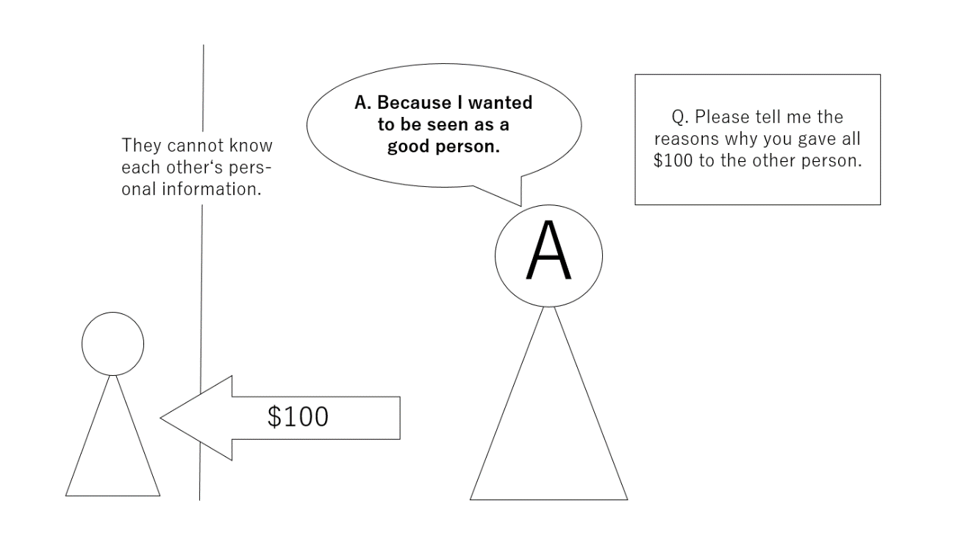
Treatment condition (Altruistic motivation)
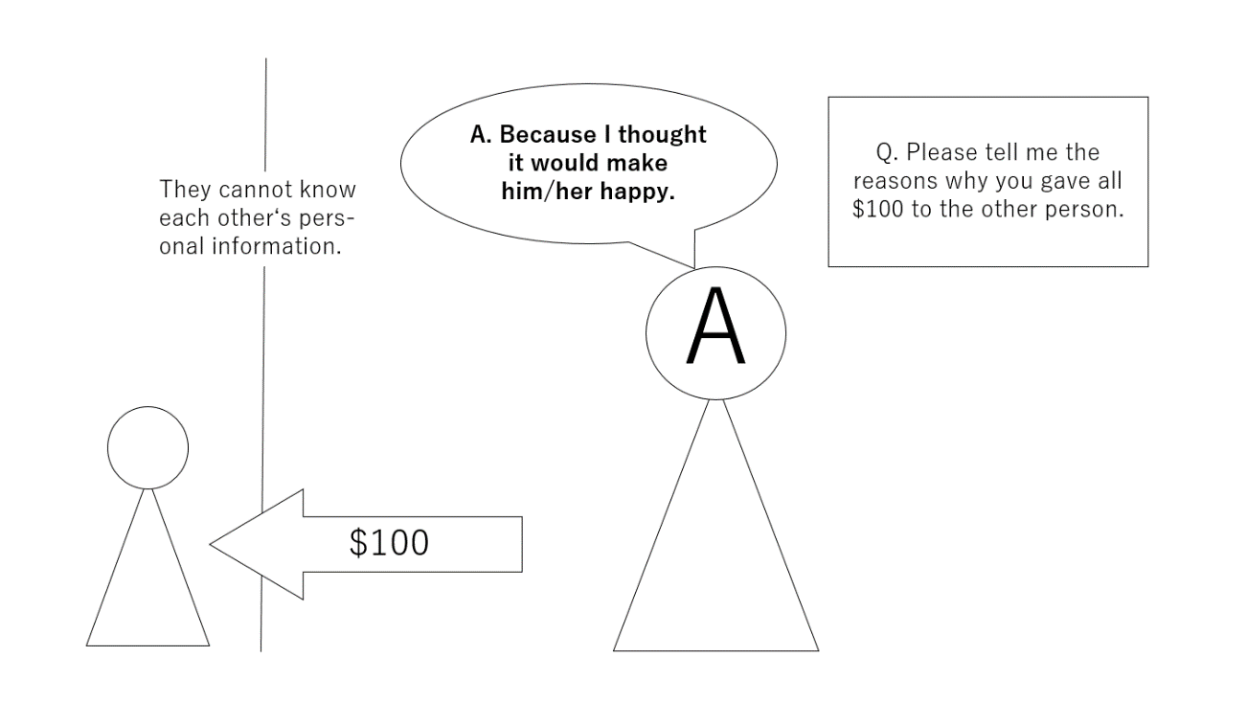

Control condition
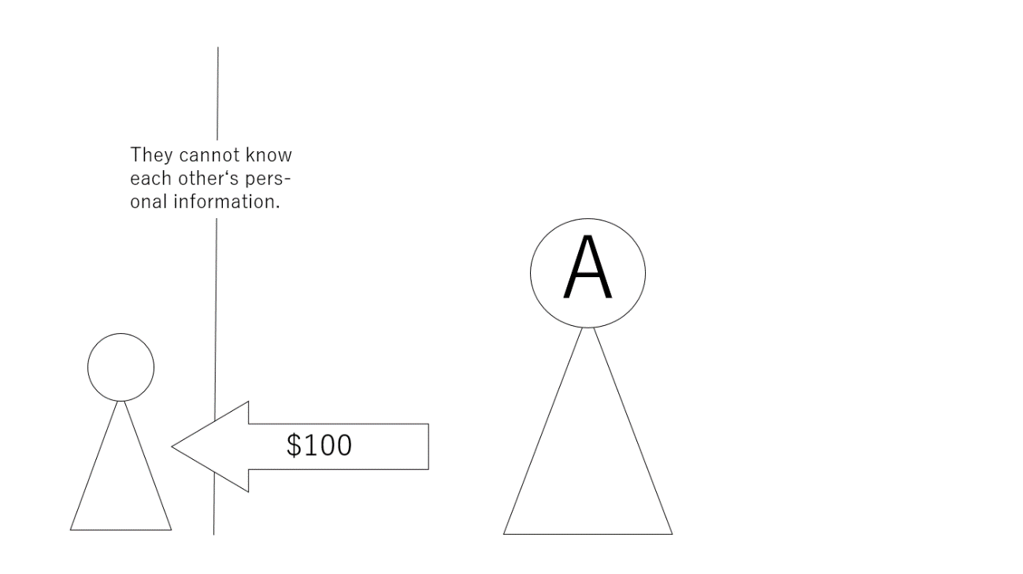

References
Hashimoto, H., & Yamagishi, T. (2013). Two faces of interdependence: Harmony seeking and rejection avoidance. Asian Journal of Social Psychology, 16(2), 142–151. https://doi.org/10.1111/ajsp.12022
Kikuchi, M., Watanabe, S., & Yamagishi, T. (1997). Judgment accuracy of other's trustworthiness and general trust: An experimental study. The Japanese Journal of Experimental Social Psychology, 37(1), 23-26. https://doi.org/10.2130/jjesp.37.23
Kosugi, M., & Yamagishi, T. (1998). General trust and judgments of trustworthiness. The Japanese Journal of Psychology, 69(5), 349–357. https://doi.org/10.4992/jjpsy.69.349
Yamagishi, T. (1998). Shinrai no kōzō [The structure of trust]. University of Tokyo Press.
Ye, N., Teng, L., Yu, Y., & Wang, Y. (2015). “What’s in it for me?”: The effect of donation outcomes on donation behavior. Journal of Business Research, 68(3), 480–486. https://doi.org/10.1016/j.jbusres.2014.09.015

