Letters on Evolutionary Behavioral Science
Supplementary Materials

An empirical investigation on the sexual selection hypothesis of human phenotypic diversity: A test in Okinawa and Mainland Japan

Saori Nojo^{1, 2*}, Ryosuke Kimura³, Yasuo Ihara²

¹National Institute of Technology, Kisarazu College, Kiyomidaihigashi 2-11-1, Kisarazu, Chiba 292-0014, Japan
²University of Tokyo, Hongo 7-3-1, Bunkyoku, Tokyo 113-0033, Japan
³University of the Ryukyus, Uehara 207, Nishihara-cho, Okinawa, 903-0215, Japan
*Author for correspondence (nojo@j.kisarazu.ac.jp)

S1. Own-group preference for the lateral view of the face
In the analysis of own-group preference described in the main text, we used the anterior views of composite faces as target faces. However, it has been pointed out that the difference in facial metrics between Okinawa Islanders and Mainland Japanese are also found in the lateral view of the face (Miyazato et al., 2014). Hence, we did an additional analysis on participants' ratings on the lateral views of target faces.
In the main analysis, we used anterior-view target faces, each of which was a composite of anterior-view facial photographs of three persons. From the lateral-view photographs of the same three persons, we made lateral-view composites, using Abrosoft FantaMorph software, for a subset of the target faces (8 OI and 8 MJT targets for each sex). For each of these targets, left-lateral, right-lateral, and anterior composites were presented in a separate sheet, and rated by all participants. These additional ratings were done after the participants finished the ratings for the main analysis.
Figure S1 shows the means and the standard deviations of the ratings for the additional sheets with anterior- and lateral-view target faces, which is quite similar to Figure 3. Table S1 gives parameter estimates. The general tendency of the results was comparable to the main analysis; in particular, the interaction of target's and participant's populations was significant in the female participants for long-term attractiveness (b₃=0.37), suggesting that women rated the own-population targets higher, though, unlike in the main analysis, the same interaction for trustworthiness fell a little short of statistical significance (b₃=0.28). Significant main effects of target's population on women's ratings were observed for long-term (b₁=0.74) and short-term (b₁=0.75) attractiveness and for trustworthiness (b₁=0.77), where OI targets were rated higher than MJT targets. We also found significant effects of participant's population in female participants on their ratings for trustworthiness (b₂=−1.04) and in male participants for short-term attractiveness (b₂=−0.66), indicating lower ratings by OI than MJT participants.

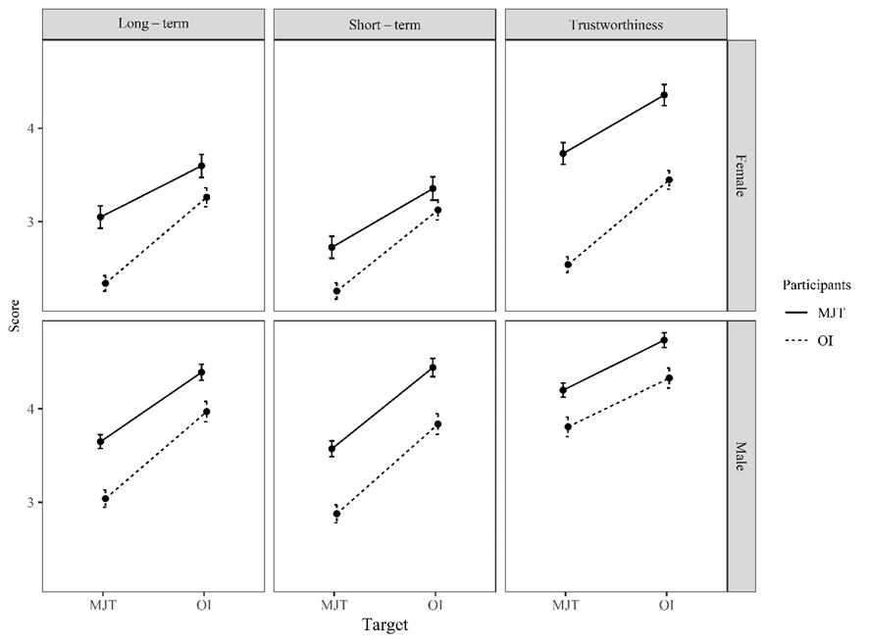
Figure S1. Means and standard deviations of the ratings for the analysis of own-group preference (with anterior- and lateral-view target faces)

Table S1. MCMC estimates of parameters for the analysis of own-group preference (with anterior- and lateral-view target faces)
Participant's sex | Context | Parameter | Estimate | 95%CI
Female | Long-term | b₀ (intercept) | 3.08 | [2.63, 3.52]
 |  | b₁ (target population) | 0.74 | [0.10, 1.39]
 |  | b₂ (participant population) | −0.53 | [−1.15, 0.08]
 |  | b₃ (interaction) | 0.37 | [0.09, 0.65]
 |  | s₁ (participant SD) | 1.50 | [1.30, 1.75]
 |  | s₂ (target SD) | 0.61 | [0.41, 0.94]
 | Short-term | b₀ (intercept) | 2.87 | [2.43, 3.30]
 |  | b₁ (target population) | 0.75 | [0.14, 1.38]
 |  | b₂ (participant population) | −0.35 | [−1.00, 0.30]
 |  | b₃ (interaction) | 0.23 | [−0.05, 0.52]
 |  | s₁ (participant SD) | 1.53 | [1.32, 1.77]
 |  | s₂ (target SD) | 0.58 | [0.39, 0.90]
 | Trustworthiness | b₀ (intercept) | 3.52 | [3.13, 3.90]
 |  | b₁ (target population) | 0.77 | [0.25, 1.28]
 |  | b₂ (participant population) | −1.04 | [−1.63, −0.44]
 |  | b₃ (interaction) | 0.28 | [−0.01, 0.58]
 |  | s₁ (participant SD) | 1.38 | [1.18, 1.61]
 |  | s₂ (target SD) | 0.49 | [0.32, 0.76]
Male | Long-term | b₀ (intercept) | 3.76 | [3.21, 4.31]
 |  | b₁ (target population) | 0.85 | [−0.14, 1.84]
 |  | b₂ (participant population) | −0.51 | [−1.00, 0.01]
 |  | b₃ (interaction) | 0.19 | [−0.02, 0.41]
 |  | s₁ (participant SD) | 1.45 | [1.28, 1.65]
 |  | s₂ (target SD) | 0.95 | [0.64, 1.47]
 | Short-term | b₀ (intercept) | 3.69 | [3.13, 4.24]
 |  | b₁ (target population) | 0.91 | [−0.09, 1.91]
 |  | b₂ (participant population) | −0.66 | [−1.22, −0.10]
 |  | b₃ (interaction) | 0.09 | [−0.14, 0.32]
 |  | s₁ (participant SD) | 1.64 | [1.45, 1.86]
 |  | s₂ (target SD) | 0.96 | [0.65, 1.44]
 | Trustworthiness | b₀ (intercept) | 4.27 | [3.85, 4.69]
 |  | b₁ (target population) | 0.54 | [−0.19, 1.25]
 |  | b₂ (participant population) | −0.39 | [−0.90, 0.10]
 |  | b₃ (interaction) | −0.01 | [−0.25, 0.23]
 |  | s₁ (participant SD) | 1.47 | [1.31, 1.69]
 |  | s₂ (target SD) | 0.70 | [0.47, 1.06]

S2. Additional analysis of mate-choice copying
The analysis of mate-choice copying in the main text focused on the presence or absence of interaction between participant's and model's populations, that is, whether participants' ratings on targets are more affected by the ratings made by the members of their own population than by those of the other population (i.e., model-dependent mate-choice copying). In this section, we examine the overall occurrence of mate-choice copying, whether or not it is model-dependent.
For each participant, we calculated the average rating in Section 1 and the average rating in Section 3 across targets for each combination of participant's sex, participant's and model's populations (i.e., OI and MJT), and context (i.e., long-term attractiveness, short-term attractiveness, and trustworthiness). We tested the difference between the two average ratings of the participants by the Wilcoxon signed rank test. Table S2 summarizes the results of the tests. The average ratings significantly increased for all combinations of participant's sex, participant's and model's populations, and context, except for OI males' ratings on the targets presented with MJT models for trustworthiness. In addition, for both male and female participants, the effect sizes were larger for long-term and short-term attractiveness than for trustworthiness. The greater effect of social learning in the judgement of attractiveness than that of trustworthiness is consistent with previous studies that found greater social influence on mate-choice than non-mate-choice decisions (Little et al., 2011a, 2011b, 2015).
For the effect of mate-choice copying, caution is needed: the increase of the average ratings between Sessions 1 and 3 may be partially attributable to the mere-exposure effect, because all participants rated target faces presented with model faces after they rated the same target faces presented alone. However, our finding of significant interactions of participant's and model's populations supports the role of mate-choice copying in the increase of average ratings.

Table S2. Summary of Wilcoxon signed rank tests for difference in the average ratings between Sessions 1 and 3
Participant's sex | Participant's population | Model's population | N |  | Context
 |  |  |  |  | Long-term |  |  |  | Short-term |  |  |  | Trustworthiness
 |  |  |  |  | Median | W | r |  | Median | W | r |  | Median | W | r
Female | OI | OI | 60 |  | 0.8 | 1563.5 | 0.708*** |  | 0.9 | 1361 | 0.738*** |  | 0.5 | 1147.5 | 0.410**
 |  | MJT | 60 |  | 0.9 | 1292 | 0.709*** |  | 1 | 1221 | 0.727*** |  | 0.4 | 1245.4 | 0.404**
 | MJT | OI | 30 |  | 0.85 | 279.5 | 0.423*** |  | 1 | 356.5 | 0.750*** |  | 0.6 | 317.5 | 0.425**
 |  | MJT | 30 |  | 0.875 | 273.5 | 0.552** |  | 1 | 367.5 | 0.676*** |  | 0.4 | 255.5 | 0.537*
Male | OI | OI | 60 |  | 0.9 | 1476 | 0.615*** |  | 0.7 | 1646 | 0.747*** |  | 0.5 | 1195 | 0.233*
 |  | MJT | 60 |  | 0.7 | 1158 | 0.435*** |  | 0.7 | 1288 | 0.602*** |  | 0.3 | 987 | 0.233
 | MJT | OI | 67 |  | 1.05 | 1846.5 | 0.719*** |  | 0.8 | 1832 | 0.667*** |  | 0.4 | 1401.5 | 0.402***
 |  | MJT | 67 |  | 0.85 | 1793.5 | 0.637*** |  | 0.7 | 1795 | 0.599*** |  | 0.5 | 1406 | 0.470***
r denotes the effect size. *p<0.05, **p<0.01, ***p<0.001.

S3. Effects of participants' personal attributes on mate-choice copying
We asked the participants to report their personal attributes such as age and the number of romantic partners they had ever had, and to fill the Mate Value Invention (MVI; Kirsner et al., 2003) and Rosenberg Self-Esteem Scale (RSE; Rosenberg, 1965; Yamamoto et al., 1982). MVI was translated into Japanese by the authors. We calculated the average increase of ratings from Session 1 to Session 3 for each person and obtained the correlation coefficients between the average increase of ratings and the personal attributes (Table S3). No significant correlation was detected. Therefore, we did not find any evidence for the effect of the participants' personal attributes on the extent of mate-choice copying.

Table S3. Correlation coefficients between the average increase of ratings between Sessions 1 and 3 and participants' personal attributes
Participant |  |  | Attributes
Population | Sex | Context | Age | Romantic partners | MVI | RSE
MJT | Female | Long-term | 0.048 | 0.007 | 0.130 | −0.160
 |  | Short-term | −0.200 | 0.042 | 0.160 | −0.250
 |  | Trustworthiness | 0.085 | 0.110 | 0.190 | −0.210
 | Male | Long-term | 0.180 | −0.047 | 0.160 | −0.070
 |  | Short-term | 0.031 | −0.140 | 0.088 | 0.030
 |  | Trustworthiness | 0.077 | −0.118 | -0.082 | −0.035
OI | Female | Long-term | -0.072 | −0.015 | 0.230 | 0.035
 |  | Short-term | 0.043 | −0.058 | 0.120 | 0.093
 |  | Trustworthiness | -0.039 | 0.063 | 0.086 | 0.140
 | Male | Long-term | 0.002 | 0.111 | −0.013 | 0.025
 |  | Short-term | 0.043 | 0.094 | −0.029 | −0.060
 |  | Trustworthiness | 0.028 | 0.100 | 0.110 | −0.060

References
Kirsner, B. R., Figueredo, A. J., & Jacobs, W. J. (2003). Self, friends, and lovers: Structural relations among Beck Depression Inventory scores and perceived mate values. Journal of Affective Disorders, 75, 131–148. https://doi.org/10.1016/S0165-0327(02)00048-4
Little, A. C., Caldwell, C. A., Jones, B. C., & DeBruine, L. M. (2015). Observer age and the social transmission of attractiveness in humans: younger women are more influenced by the choices of popular others than older women. British Journal of Psychology, 106, 397-413. https://doi.org/10.1111/bjop.12098
Little, A. C., Jones, B. C., & DeBruine, L. M. (2011a). Facial attractiveness: Evolutionary based research. Philosophical Transactions of the Royal Society B: Biological Sciences, 366, 1638–1659. https://doi.org/10.1098/rstb.2010.0404
Little, A. C., Jones, B. C., DeBruine, L. M., & Caldwell, C. A. (2011b). Social learning and human mate preferences: A potential mechanism for generating and maintaining between-population diversity in attraction. Philosophical Transactions of the Royal Society B: Biological Sciences, 366, 366–375. https://doi.org/10.1098/rstb.2010.0192
Miyazato, E., Yamaguchi, K., Fukase, H., Ishida, H., & Kimura, R. (2014). Comparative analysis of facial morphology between Okinawa Islanders and mainland Japanese using three-dimensional images. American Journal of Human Biology, 26, 538–548. https://doi.org/10.1002/ajhb.22560
Rosenberg, M., (1965). Society and the Adolescent Self-Image. Princeton University Press, Princeton. https://doi.org/10.1515/9781400876136
Yamamoto, M., Matsui, Y., & Yamanari, Y. (1982). The structure of perceived aspects of self. Japanese Journal of Educational Psychology, 30, 64–68. https://doi.org/10.5926/jjep1953.30.1_64

