**SUPPLEMENTARY MATERIAL 1**

Syntactic structure influences speech-gesture synchronization

*Kei Kashiwadate1 Tetsuya Yasuda1 Koji Fujita2 Sotaro Kita3 Harumi Kobayashi1\**

1Tokyo Denki University 2Kyoto University 3University of Warwick

* Author for correspondence (h-koba@mail.dendai.ac.jp)

***Letters on Evolutionary Behavioral Science***

## Examination of the material

*Preference of Interpretations*

## In examining the differences in accompanying gestures, it was necessary to investigate the participants’ interpretation preferences when only language was presented without gestures. It has been reported that the left branching interpretation is preferably taken by a sequential processing in a Japanese phrase consisting of three words (Ito, et al., 2015). Unlike phrases consisting of three words with at least two different interpretations, there are at least three different interpretations possible for phrases consisting of 4 words. Furthermore, it is not clear which interpretation is preferably interpreted by the native speakers of Japanese. With this, we performed a picture selection questionnaire survey.

*Picture selection task*

The picture selection task was performed by 77 participants. They were all Japanese university students. The questionnaire included two target items and two filler items. Each target item was a phrase that had three possible interpretations. One item was [*kuroi*] [*shippo-no*] [*ookina*] [*neko*] in Japanese (i.e., [black] [tail-GEN] [big] [cat]). This can be interpreted as any of (a) “a cat with a black big tail,” (b) “a black cat with a big tail,” and (c) “a big cat with a black tail” (Figure 5). Another item was [*shiroi*] [*hana-no*] [*ookina*] [*zou*] in Japanese (i.e., [white] [trunk-GEN] [big] [elephant]). This can be interpreted as any of “an elephant with a white big trunk,” “a white elephant with a big trunk,” and “a big elephant with a white trunk.” Participants chose a better match for each expression among the corresponding three drawings (e.g., a cat with a black big tail, a big cat with a black tail, and a black cat with a big tail).

Figure 6 shows the proportions of object selections. When the phrase “*kuroi* *shippo-no* *ookina* *neko*” was shown, the picture of “a big cat with a black tail” (i.e., Big-cat structure) was selected most (70%, 54/77). Likewise, when the phrase “*shiroi hana-no ookina zou*” was shown, the picture of “a big elephant with a white trunk” (i.e., Big-cat structure) was selected most (74%, 57/77). Some people selected the picture of “a black cat with a big tail” when the phrase “*kuroi* *shippo-no* *ookina* *neko*” was shown (23%, 18/77). Some people selected the picture of “a white elephant with a big trunk” when the phrase “*shiroi hana-no ookina zou*” was shown (23%, 18/77). “A cat with a black big tail” and “an elephant with a white big trunk” (i.e., Black-big-tail structure) were rarely selected (6%, 5/77; 3%, 2/77).

As a result, people showed preferences in ambiguous phrases that have three possible interpretations. Big-cat structure was interpreted dominantly in our experiment. In addition, a substantial number of participants chose Big-tail structure interpretation. Interpretation based Black-big-tail structure was rare. It was confirmed that the stimuli we used reflect the two major interpretations by Japanese native speakers (i.e., Big-cat structure and Big-tail structure).

**Reference**

Ito, K., Arai, M., & Hirose, Y. (2015). The interpretation of phrase-medial prosodic prominence in Japanese: is it sensitive to visual and discourse context? Language, Cognition and Neuroscience, 30, 167-196. https://doi.org/10.1080/01690965.2013.864778

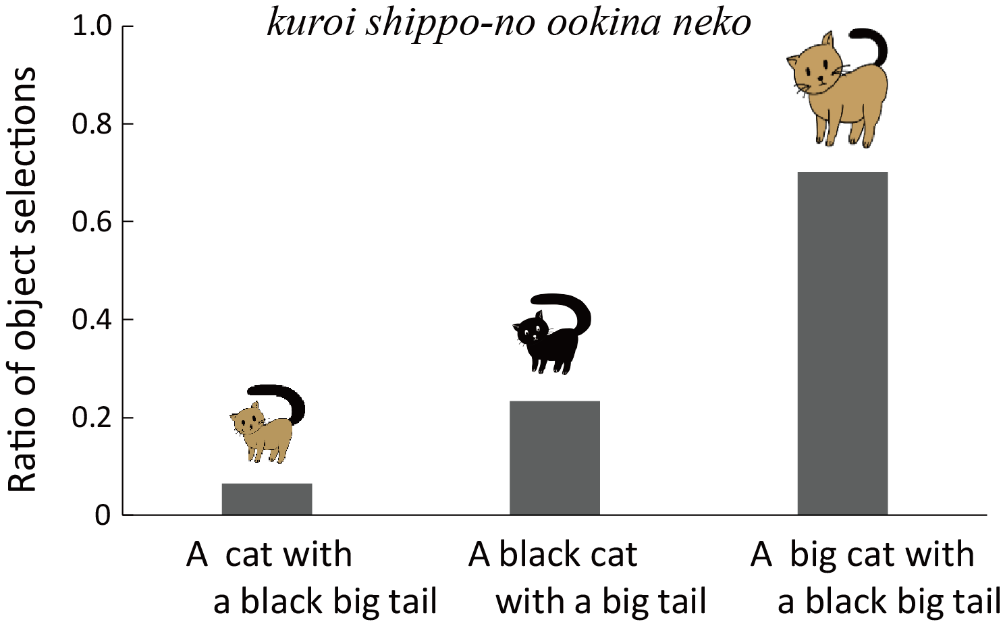

Figure 6. Ratios of object selections.



Figure 5. Branching structures of three possible interpretations.

(a): Black-big-tail structure {{*kuroi*, {*shippo-no*, *ookina*},} *neko*};

(b): Big-tail structure {{*kuroi*}, {{*shippo-no*, *ookina*}, *neko*}};

(c): Big-cat structure {{*kuroi*, *shippo-no*}, {*ookina*, *neko*}}