Supplementary file 2

Results

Manipulation check of expectation
Figures 3 and 4 show the means of expectation by gender and conditions. To test whether the manipulation of group knowledge was success, a 2 (gender) × 2 (threat condition) × 5 (knowledge) ANOVA on expectation revealed a significant main effect of knowledge (F (4, 620) = 72.27, p< .01, η²_{e} = .32). Other main effects (Fs (1, 155) <0.06, ps> .80, η²_{e}s < .00) and interaction effects (Fs (1/4, 155/620) <0.86, ps> .71, η²_{e} s< .07) were not significant. A 2 (threat condition) × 5 (knowledge) ANOVA by gender also revealed a significant main effect of knowledge (Fs (4, 620) >32.99, ps< .01, η²_{e}> .31) and no other significant effects (Fs (1/4, 155/620) <1.07, ps> .35, η²_{e}s < .01). Multiple comparisons using the Holm’s method in each gender group revealed that the ingroup-bilateral condition was significantly different from the other four conditions among both women and men (ts(155) >6.38, ps < .01, ds > .53). These results showed that ingroup cooperation was enhanced only in the situation wherein participants can expect reciprocity from their partner in both genders. This is consistent with previous studies (e.g., Yamagishi, Jin, & Kiyonari, 1999). Therefore, the manipulation of the knowledge of group belonging was successful. Holm’s method also revealed significant differences between the unknown condition and the outgroup-bilateral condition (ts(155) > 2.63, ps < .04, ds > .18), and between the outgroup-bilateral and unilateral condition (ts(155) > 3.36, ps < .01, ds > .24) among both women and men. Only men showed a significant difference between the ingroup-unilateral condition and the outgroup-bilateral condition (t(155) = 4.13, p< .01, d = .33).

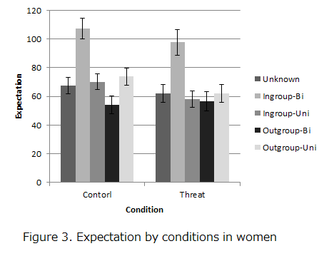
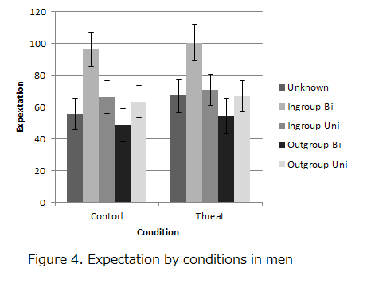

The additional analysis of rewards – post-hoc comparisons
To investigate whether the effect of outgroup threat priming on cooperative behavior differed by gender, we performed 2 (threat condition) × 5 (knowledge) ANOVAs separately by gender. In both gender groups, significant main effects of knowledge (Female: Fs(4, 332) = 16.82, p < .01, η²_{e}= .17, Male: F(4, 288) = 7.67, p < .01, η²_{e} = .10) were found. However, there was no significant main effect of threat condition (Fs (1, 83_{female}/72_{male}) < 0.37, ps > .54, η²_{e}s < .01) or any interaction effects (Fs (4, 332_{female}/288_{male}) < 1.39, ps > .25, η²_{e}s < .02).
To examine the differences within the pattern of cooperation behavior in each of the five knowledge conditions by outgroup threat condition and gender, one-way ANOVAs were performed within each condition (control vs. threat) and gender (women or men) respectively. Among women, there were significant effects of group knowledge (Control: Fs(4, 164_{control} / 168_{threat}) > 8.81, ps < .01, η²_{e} > .17). A post-hoc comparison using Holm’s test revealed that rewards in the ingroup-bilateral condition significantly exceeded rewards of the other four conditions (ts(42_{control}, 43_{threat}) > 3.09, ps < .02, ds > .39) in both control and threat conditions. As expected, these results showed that women favored the ingroup based on reciprocity regardless of the cued outgroup threat. On the other hand, among men, a significant difference was found only in the control condition (F(4, 144) = 6.10, p < .01, η²_{e} = .15). Post-hoc comparisons showed that rewards in the ingroup-bilateral condition were above the unknown and outgroup-bilateral condition (ts(36) > 3.20, ps < .03, ds > .48). The rewards in the outgroup-unilateral condition did not significantly exceed the ones in the ingroup-bilateral condition (t(36) = 2.72, p = .08, d = .47), but the effect sizes were almost equal when examining the ingroup-unilateral condition and the outgroup-bilateral condition. As expected, the rewards in the ingroup-bilateral condition were higher than the other conditions. However, in the threat condition, contrary to our predictions, there was no significant difference (F(4, 144) = 2.18, p = .11, η²_{e} = .06). In other words, the results showed that male participants did not show any bias after being presented with the cued outgroup threat.

