Selfishness is attributed to men who help young women: Signaling function of male altruism

Supplementary Materials

Yuta Kawamura^{1, 2}, Takashi Kusumi¹

¹ Graduate School of Education, Kyoto University, Yoshida-Honmachi, Sakyo-ku, Kyoto 606-8501, Japan.
² Japan Society for the Promotion of Science, Tokyo, Japan

1. The Vignettes
The vignettes used in Study 1 were as follows: “Kazuo (or Naoko), who started working this year, goes to the office daily, which is about a 10-minute walk from a dormitory for single employees. One day, on the way to the office, he (or she) saw a woman (or man) of approximately the same age looking for something they had lost on the roadside. Kazuo (or Naoko) interacted with the woman (or man) and they started looking for the lost item together.”

The original Japanese version of the vignettes are as follows: “社会人1年目の和夫 (または直子) は、会社まで徒歩10分の独身寮から、毎日歩いて職場に通っています。ある日のこと、彼 (彼女) は会社へ向かう途中で、同年代くらいの女性 (男性) が道端で落し物を探しているところを見かけました。和夫は女性 (男性) に声をかけ、一緒になって落し物を探しました。”

2. Supplementary Measures and Results
In addition to selfish motivation, we also asked participants to evaluate helpers’ altruistic motivation (2 items: “want to be strong for recipients” and “feel pity and want to help”) and altruistic traits (4 items: how nice, altruistic, kind, and generous the helper is; adapted from Lin-Healy & Small, 2012). Both measures were rated on a 7-point scale (1 = not at all, 7 = extremely).

Although the effect size was much smaller, the results were mostly consistent with the results of selfish motivation: a man who helped a woman was seen as less altruistic than was a person who helped a member of the same sex. In Study1, the four altruistic traits items (α = .67) and two altruistic motivation items (r = .55) were averaged to obtain the dependent variables. We conducted a 2 (helper sex) × 2 (recipient sex) two-way ANOVA on altruistic traits (Figure S1). There was a significant main effect of helper sex, F(1, 1580) = 6.17, p = .013, $η_{p}^{2}$ = .004, and a significant interaction between helper sex and recipient sex, F(1, 1580) = 4.82, p = .028, $η_{p}^{2}$ = .003. A man who helped a woman was viewed as less altruistic than was a man who helped another man (F(1, 1580) = 7.02, p = .008, $η_{p}^{2}$ = .004) or a woman who helped a woman (F(1, 1580) = 12.55, p < .001, $η_{p}^{2}$ = .008). However, a woman who helped a man did not significantly differ in perceived altruistic traits from a helper who was the same sex as the recipient (Fs < 0.16, ps > .69, $η_{p}^{2}$s < .001). A similar pattern emerged for altruistic motivation (see Figure S2): there was a significant interaction between helper sex and recipient sex, F(1, 1580) = 6.47, p = .011, $η_{p}^{2}$ = .004. Although the perceived altruistic motivation of a man who helped a woman was not significantly different from that of a man who helped a man (F(1, 1580) = 3.13, p = .077, $η_{p}^{2}$ = .002), a man who helped a woman was rated as having significantly lower altruistic motivation than was a woman who helped another woman (F(1, 1580) = 7.98, p = .005, $η_{p}^{2}$ = .005). However, a woman who helped a man had comparable scores for altruistic motivation as when the helper was the same sex as the recipient (Fs < 3.37, ps > .066, $η_{p}^{2}$s < .003).

In Study 2, the four altruistic traits items (α = .68) and the two altruistic motivation items (r = .46) were averaged to obtain the dependent variables, as in Study 1. We conducted a 2 (recipient age: young vs. old) × 2 (recipient sex: male vs. female) two-way ANOVA on altruistic traits (see Figure S3). There was a significant main effect of recipient age, F(1, 1332) = 18.52, p < .001, $η_{p}^{2}$ = .014, and a significant interaction between recipient sex and age, F(1, 1332) = 6.15, p = .013, $η_{p}^{2}$ = .005. The results were consistent with those of Study 1: that is, a man who helped a young woman was viewed as less altruistic than was a man who helped a young man (F(1, 1332) = 5.99, p = .015, $η_{p}^{2}$ = .005). Furthermore, a man who helped an old woman was rated as altruistic as a man who helped another man (F(1, 1332) = 0.87, p = .351, $η_{p}^{2}$ = .001). In addition, a man who helped a young woman was viewed as less altruistic than was a man who helped an old woman (F(1, 1332) = 28.40, p < .001, $η_{p}^{2}$ = .021). Regarding altruistic motivation, we found a significant main effect of recipient age, F(1, 1332) = 19.19, p < .001, $η_{p}^{2}$ = .014; although the interaction between recipient sex and age was not significant (F(1, 1332) = 1.88, p = .170, $η_{p}^{2}$ = .001), the pattern was similar to the results for altruistic traits (see Figure S4).

3. Reference
Lin-Healy, F., & Small, D. A. (2012). Cheapened altruism: Discounting personally affected prosocial actors. Organizational Behavior and Human Decision Processes, 117, 269–274. doi:10.1016/j.obhdp.2011.11.006

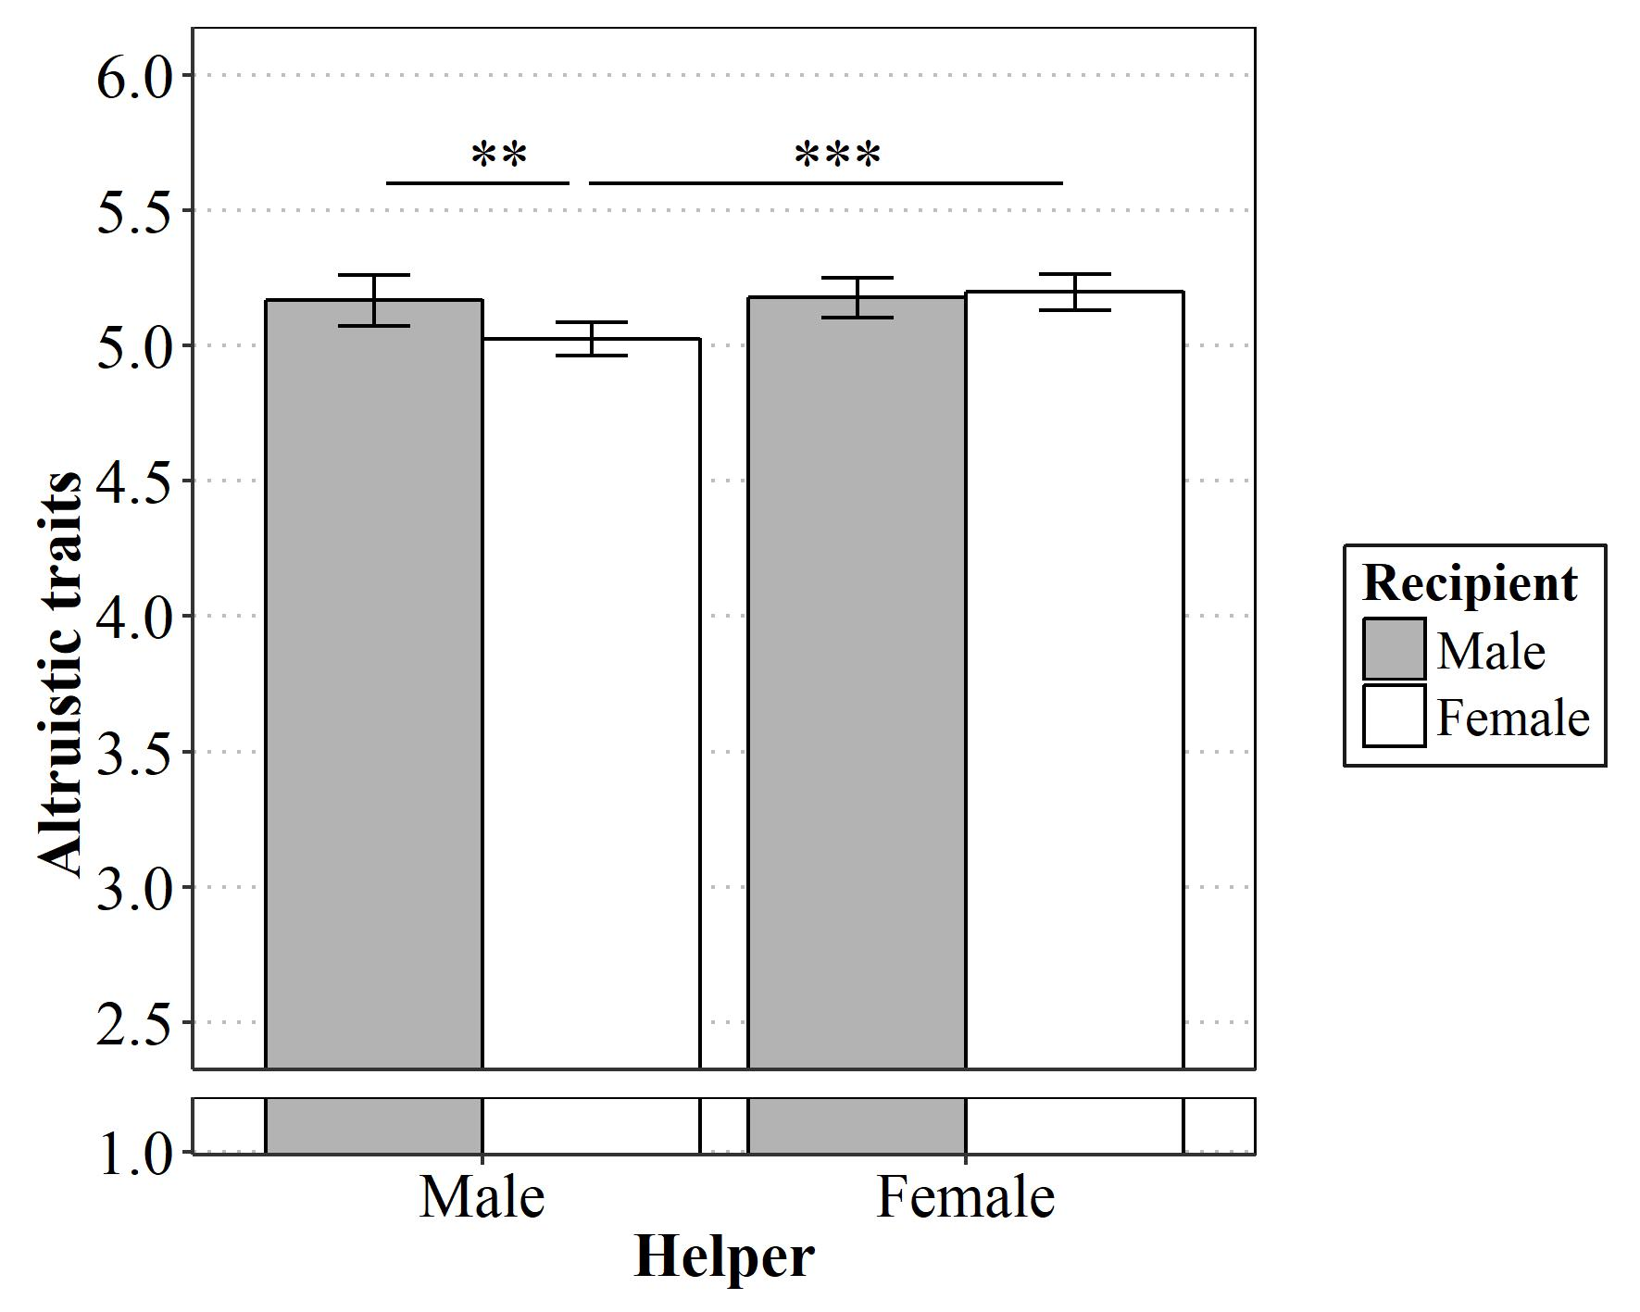
Figure S1. Mean ratings (95% CIs) of altruistic traits across each condition in Study 1. Simple main effects at **p < .01, ***p < .001.

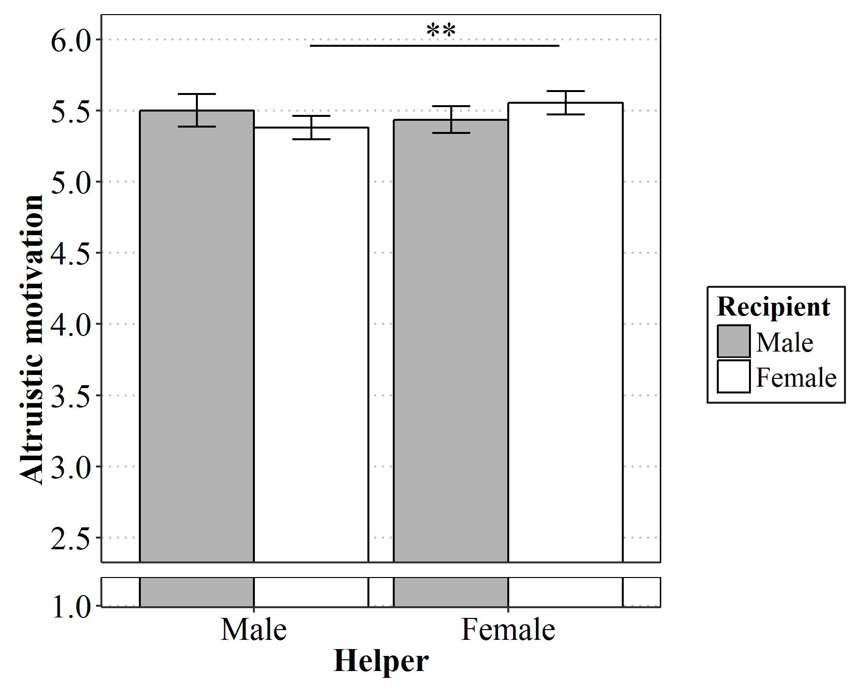
Figure S2. Mean ratings (95% CIs) of altruistic motivation across each condition in Study 1. Simple main effect at **p < .01.

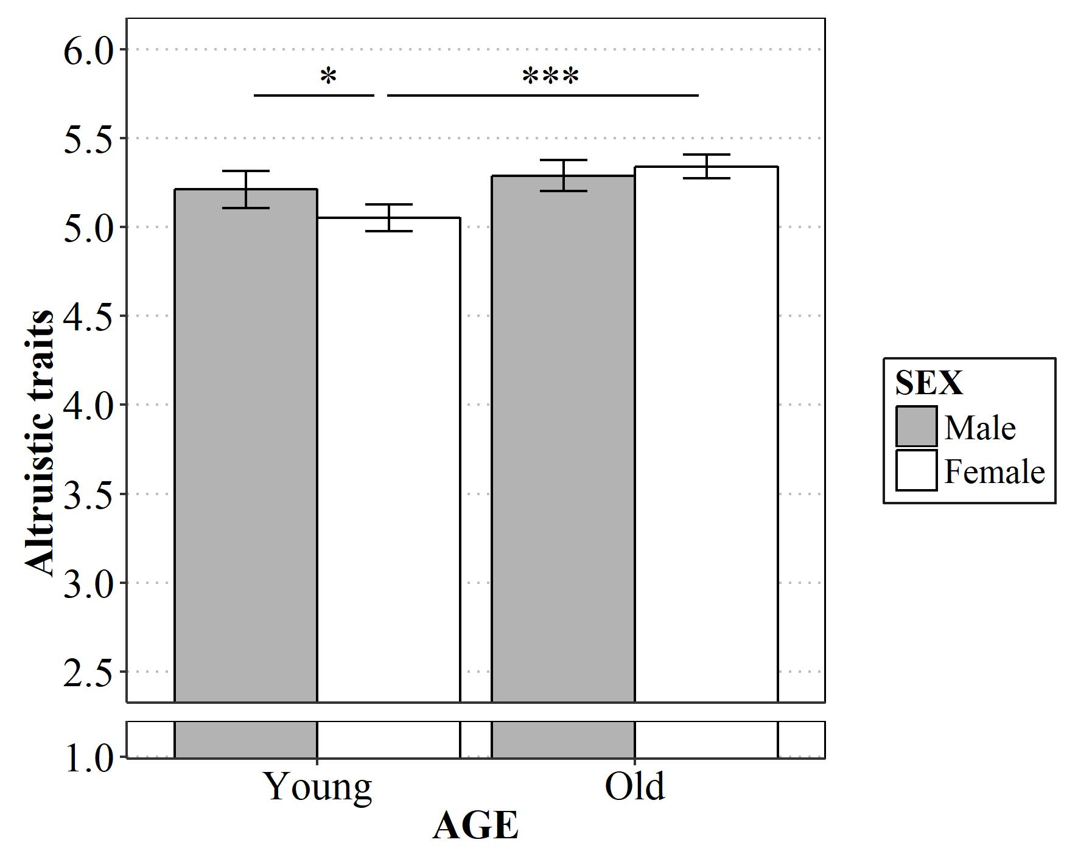
Figure S3. Mean ratings (95% CIs) of altruistic traits across each condition in Study 2. Simple main effects at *p < .05, ***p < .001.

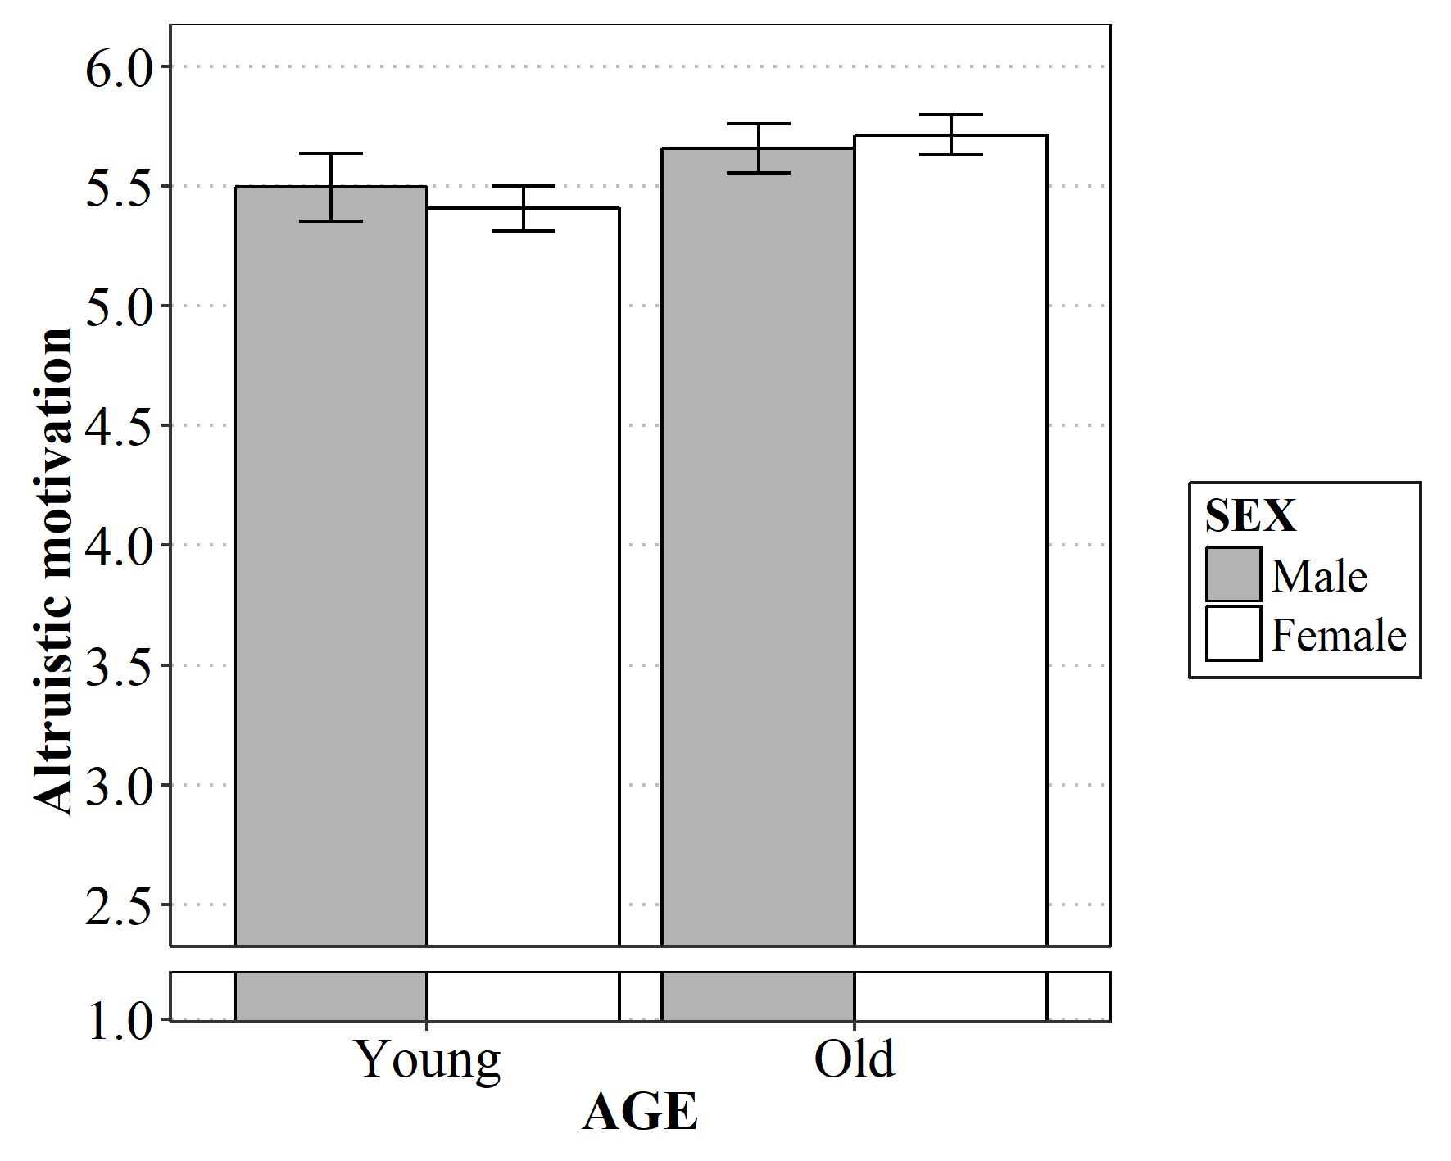
Figure S4. Mean ratings (95% CIs) of altruistic motivation across each condition in Study 2.

