These graphs include Jacksonville, NC, an MSA with a sex ratio 13.6 standard deviations above the mean. Jacksonville's demographics are strongly influenced by the United States Marine Corps' Marine Corps Base Camp Lejeune and Marine Corps Air Station New River. The city of Jacksonville has the youngest average age of any US city (22.8 years).
Figure S1: Proportions of households with children headed by single mothers
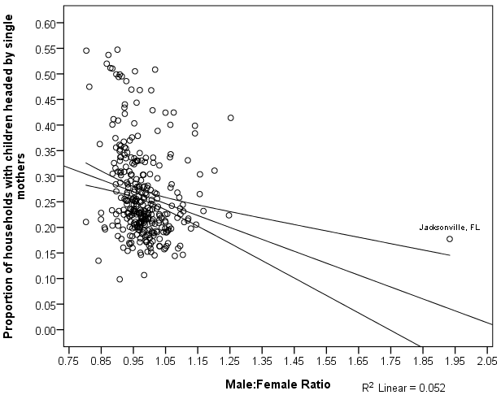
Note: Regression line with 95% confidence interval depicted.

Figure S2: Proportions of households with children headed by single fathers
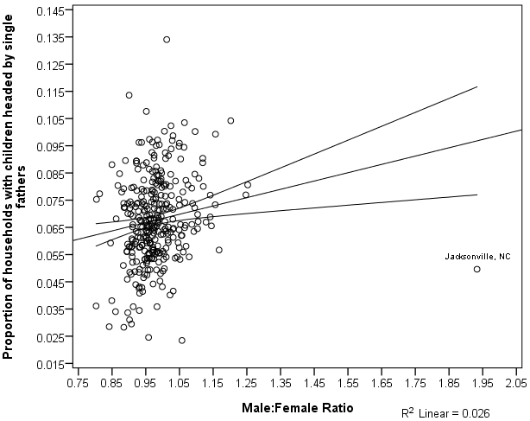
Note: Regression line with 95% confidence interval depicted.

Figure S3: Proportions of married couple households who have children out of all married couple households
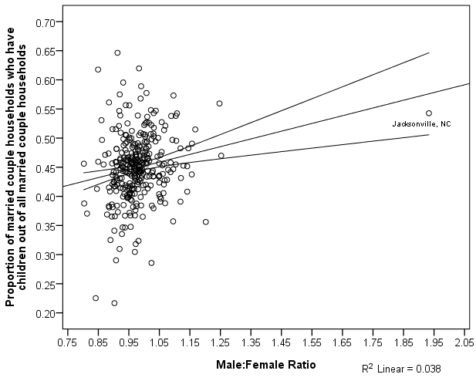
Note: Regression line with 95% confidence interval depicted.

